Second meeting of the intersessional process considering the Strategic Approach
and the sound management of chemicals and waste beyond 2020
Stockholm, Sweden, 13-15 March 2018
Item 5 of the provisional agenda*
Timetable for the process

Timetable for the intersessional process
Note by the secretariat
- The secretariat has the honour to provide, in the annex to the present note, a proposed overall timetable in moving forward.

- The fourth session of the Conference decided, in resolution IV/4, that the intersessional process should include, in principle, two meetings before the third meeting of the Open-ended Working Group and one meeting between the third meeting of the Open-ended Working Group and the fifth session of the International Conference on Chemicals Management (ICCM5). The Conference also specified that meetings of the intersessional process should, as far as possible, be held back-to-back with other relevant meetings and processes.

- The Conference also directed the Open-ended Working Group to consider the need to call for an additional meeting of the intersessional process before (ICCM5).

- Participants may wish to keep the timetable in mind in the deliberations. In addition, those wishing to host the future meeting of the intersessional process may wish to indicate so at this second meeting.

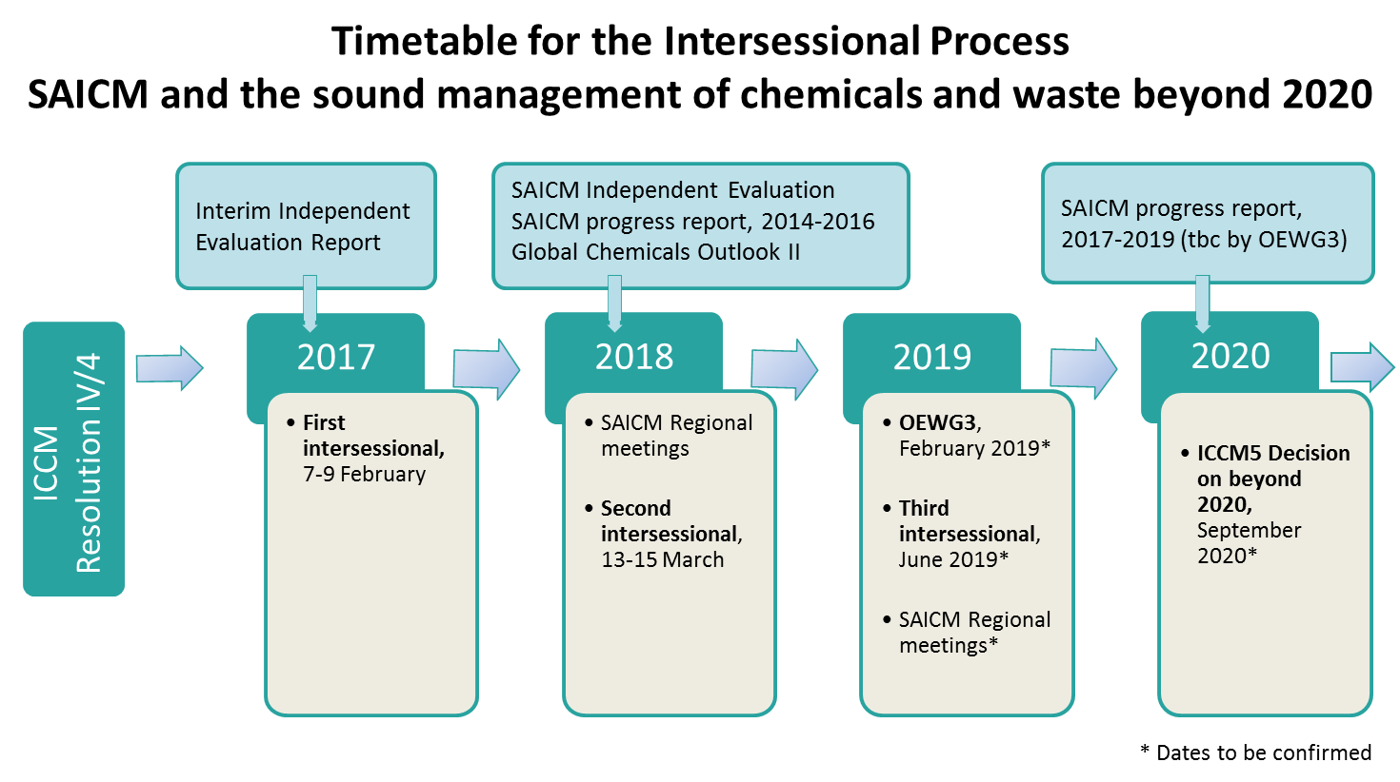

*SAICM/IP.2/1

