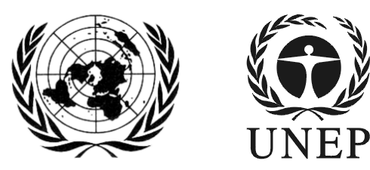 | SAICM/RM/2018/2
 |  | Distr.: General  5 January 2018  English only
Regional meeting on the Strategic Approach to International Chemicals Management
Update on the Quick Start Programme and its trust fund
I. Financial update of the Trust Fund

- The Quick Start Programme was established in 2006 by the International Conference of Chemicals Management (ICCM) at its first session to support initial capacity-building activities for the implementation of the Strategic Approach to International Chemicals Management (SAICM). From the date of its establishment to December 2017, the Quick Start Programme has mobilized a total of over US$47.6 million. This amount includes approximately US$37.8 million in cash contributions to the Trust Fund and over US$9.8 million in cash and/or in-kind contributions from project implementers and Executing Agencies.

- Since 2006, the Trust Fund has received contributions from the Governments of Australia, Austria, Belgium, the Czech Republic, Finland, France, Germany, Hungary, India, Madagascar, the Netherlands, Nigeria, Norway, Pakistan, Republic of Korea, Romania, Slovenia, South Africa, Spain, Sweden, Switzerland, the United Kingdom and the United States of America, as well as from the European Union.

- All the 184 approved projects would be funded, and that the total value of the whole portfolio is approximately US$38.5 million.

II. Decision about the closure of the Trust Fund

- At its third session, the International Conference on Chemicals Management decided to extend the term for contributions to the Quick Start Programme Trust Fund until its fourth session (ICCM4). The Trust Fund is consequently closed for new contributions since ICCM4, held in Geneva from 28 September to 2 October 2015. However, the Conference agreed that funds committed to projects before the closure of the Quick Start Programme Trust Fund may be disbursed until all approved projects in the portfolio of the Programme are completed.

- The Conference delegated to the Executive Board of the Quick Start Programme the decision on the date for the full and final closure of the Quick Start Programme Trust Fund, acting on a recommendation from the secretariat. The Conference noted that this closure will take place before the fifth session of the International Conference on Chemicals Management, and that the Executive Director of the United Nations Environment Programme should be informed at least six months in advance of the closure.

- The 11th meeting of the Executive Board of the Quick Start Programme was held on 14 December 2017. At this meeting, the Board decided that the date for the full and final closure of the Trust Fund and the end of the QSP will be 31 December 2019.

III. Quick Start Programme Trust Fund projects

- Since its establishment, there have been 14 application rounds to the QSP Trust Fund. The secretariat screened project proposals for completeness and eligibility, and submitted 341 applications for appraisal by the QSP Trust Fund Implementation Committee. Over the 14 application rounds, the Committee approved 184 projects spanning 108 different countries, of which 105 are on the OECD DAC list. These include 54 Least Developed Countries (LDCs) and/or Small Island Developing States (SIDS) (Annex B, Summary of QSP projects and eligibility for support from the SAICM Quick Start Programme Trust Fund (round 1 to 14)). Regionally, 40 projects were approved in the African region, 30 in Asia and the Pacific, 28 in Latin America and the Caribbean, and 10 in Central and Eastern Europe (see figures 6 and 7 in Annex A).

- Furthermore, over 14 rounds, 129 civil society applications have been processed by the secretariat. All projects received an assessment of their compliance with eligibility and completeness criteria. Of these projects, 21 were subsequently approved by the Trust Fund Implementation Committee, which represented around 11% of total projects (see figures 2 and 3 in Annex A).

- Distribution of approved QSP projects across each of the three strategic priorities of the Programme has been a key consideration of the QSP Trust Fund Implementation Committee in reviewing projects for funding. In almost all of the 14 rounds (with the exception being round two), projects were approved addressing each of the three priorities. Overall, strategic priority A (profile/needs assessment) and strategic priority B (programmes, plans etc. building upon international agreements and initiatives) have received the greatest degree of attention (see figures 8 and 9 in Annex A). The trend in rounds 11 to 14 was for a considerably larger proportion of projects addressing strategic priority C.

- Sectoral balance has been achieved across the 14 rounds. Overall, the environment sector dominated in the total number of projects, followed by health, other/multisector, agriculture, industry, labour and science (see figures 4 and 5 in Annex A). However, the trend over time has been toward greater sectoral coverage of projects as the rounds progressed.

- As at December 2017, the secretariat had finalised or was in the process of finalising funding agreements for all the approved projects. Detailed information about all the approved projects can be found in Annex D Status of projects funded under the Quick Start Programme Trust Fund.

IV. Quick Start Programme non-Trust Fund

- At its first meeting, held from 26 to 27 April 2006, the Quick Start Programme (QSP) Executive Board requested the secretariat to draft a reporting form for non-Trust Fund QSP contributions. The draft form was prepared to assist reporting on non-Trust Fund contributions as well as in relation to determining participation in meetings of the Executive Board. The draft form was revised and adopted by the Board at its second meeting, held from 23 to 24 April 2007. In advance of each Executive Board meeting, contribution declaration forms are received and compiled by the secretariat.
- From 2006 to 2017, the declared non-Trust Fund contributions reached a combined total of approximately US$88.5 million. The contributors for 2006–2017 have been the Governments of: Canada, Japan, Switzerland, Sweden, the United Kingdom and the United States of America. Intergovernmental organizations: the Food and Agriculture Organization of the United Nations (FAO), the United Nations Development Programme (UNDP), the United Nations Environment Programme (UN Environment), the United Nations Industrial Development Organization (UNIDO), the United Nations Institute for Training and Research (UNITAR), the World Health Organization (WHO), and the Organisation for Economic Cooperation and Development (OECD). Additional non-governmental donors have been: Argentine Society of Doctors for the Environment (AAMMA), the BASF, the Dow Chemical Company (DOW), International Council of Chemical Associations (ICCA), the International POPs Elimination Network (IPEN), and the International Society of Doctors for the Environment (ISDE).

V. Secretariat support to the Quick Start Programme

- The functions of the secretariat in relation to the Quick Start Programme are set out in ICCM resolution I/4 and include:
  - To facilitate meetings of the QSP Trust Fund Implementation Committee and the Quick Start Programme Executive Board; and
  - To provide administrative support to the Quick Start Programme and its trust fund.

15. As at December 2017, the staffing levels in the SAICM secretariat working on the Quick Start Programme comprised a P-3 Programme Management Officer and a P-2 Associated Programme Management Officer.

- Meeting facilitation of the QSP Trust Fund Implementation Committee and the Quick Start Programme Executive Board
- As of December 2017, the secretariat had convened and serviced eleven meetings of the Executive Board and eighteen meetings of the Trust Fund Implementation Committee. The secretariat coordinates preparation and follow-up for each meeting with the meeting chair or co-chairs. For each meeting, the secretariat develops detailed reports on the status of the Trust Fund and the projects funded through the Fund, and other issues related to the administration of the Quick Start Programme.

- Administrative support to the Quick Start Programme and its Trust Fund
- As of December 2017, 179 agreement documents had been completed and signed from the 184 approved projects over the 14 rounds. The lengthy consultations with project implementers and Executing Agencies are delaying the processing of these agreements. In parallel, the secretariat is also focusing on the closure of projects working very closely with project implementers, Executive Agencies and UN Environment Administration.

- As part of its administrative duties, the secretariat monitors the progress of funded projects. Each project must submit half-yearly narrative and financial reports, a mid-term and/or final monitoring and evaluation report, as well as final narrative and expenditure reports and the deliverables produced by the project. The secretariat oversees the submission of these documents, gives feedback; supports project implementers providing them guidance; requests payments; and assesses the overall performance of the projects. Moreover, the secretariat supports and addresses the budget revision and extension requests, working with project implementers, UN Environment Administration and the QSP Trust Fund Implementation Committee. If remedial action is required, the secretariat consults the QSP Trust Fund Implementation Committee for guidance.

- The secretariat also facilitates the conclusion of agreements with donors and any necessary reporting to contributors and donors. These tasks are coordinated with UN Environment Chemicals and Health Branch Administration and the Treasury Section of the Budget and Financial Management Service of the United Nations Office at Nairobi.

- Information sharing and communications
- The secretariat continues to gradually increase its efforts in dissemination of information, particularly lessons learned on the Quick Start Programme. For example, outreach materials developed such as infographics showing information and graphics of all QSP projects (Annex A, figures 13 to 18), have been distributed in different events – e.g. briefings organised by the Geneva Environment Network.

- The secretariat has revamped the SAICM web page. The Quick Start Programme section has been modified to be more user-friendly and provide an easier access to information - the link to the QSP is now at the front page. One of the changes introduced is that it now includes a story from the field, which describes from beneficiaries’ perspective the impact that a particular QSP project has had in their lives. Furthermore, the impact evaluation of the Quick Start Programme is also made available. In addition, the development of an interactive map with information about all the projects is planned. The secretariat is working on these improvements and closely working with the implementers drafting the stories together.

- Moreover, the SAICM secretariat has made presentations on the Quick Start Programme and other topics relevant to SAICM to various stakeholders involved in projects. In addition, the secretariat is responding to different specific information demands working with partners such as the Special Programme secretariat, UN Environment Regional Chemicals and Waste Coordinators, UN Environment Global Environment Facility team, and the Secretariat of 10 Year Framework of Programmes on Sustainable Consumption and Production, among others.

- The Inter-Organization Programme for the Sound Management of Chemicals (IOMC) meetings usually have an item dedicated to the Quick Start Programme and its trust fund. The Strategic Approach secretariat thus briefs the IOMC Participating Organisations on the QSP. In addition, the ICCM5 Bureau is also briefed at its meetings on the developments of the Programme.

- The secretariat continues to work identifying opportunities to showcase projects and improve visibility. In addition, a communications strategy has been drafted for the Strategic Approach, including the Quick Start Programme.

Annex A: Quick Start Programme Statistics and Figures

Figure 1. Number of applications vs projects approved per round, rounds 1 to 14.
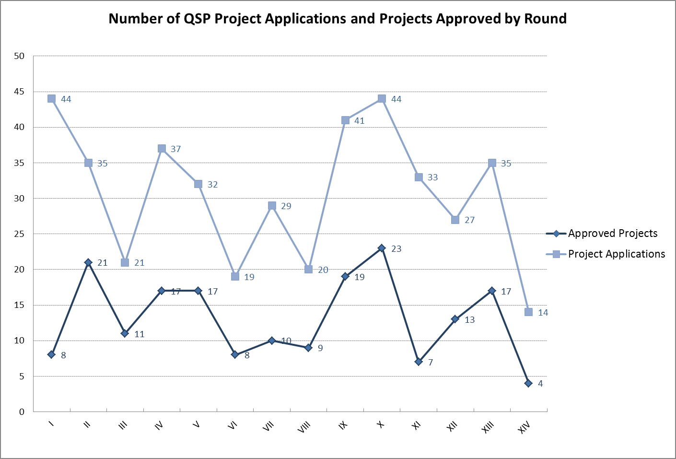

Figure 2. Approved QSP Projects – Government versus Civil Society (number of projects)
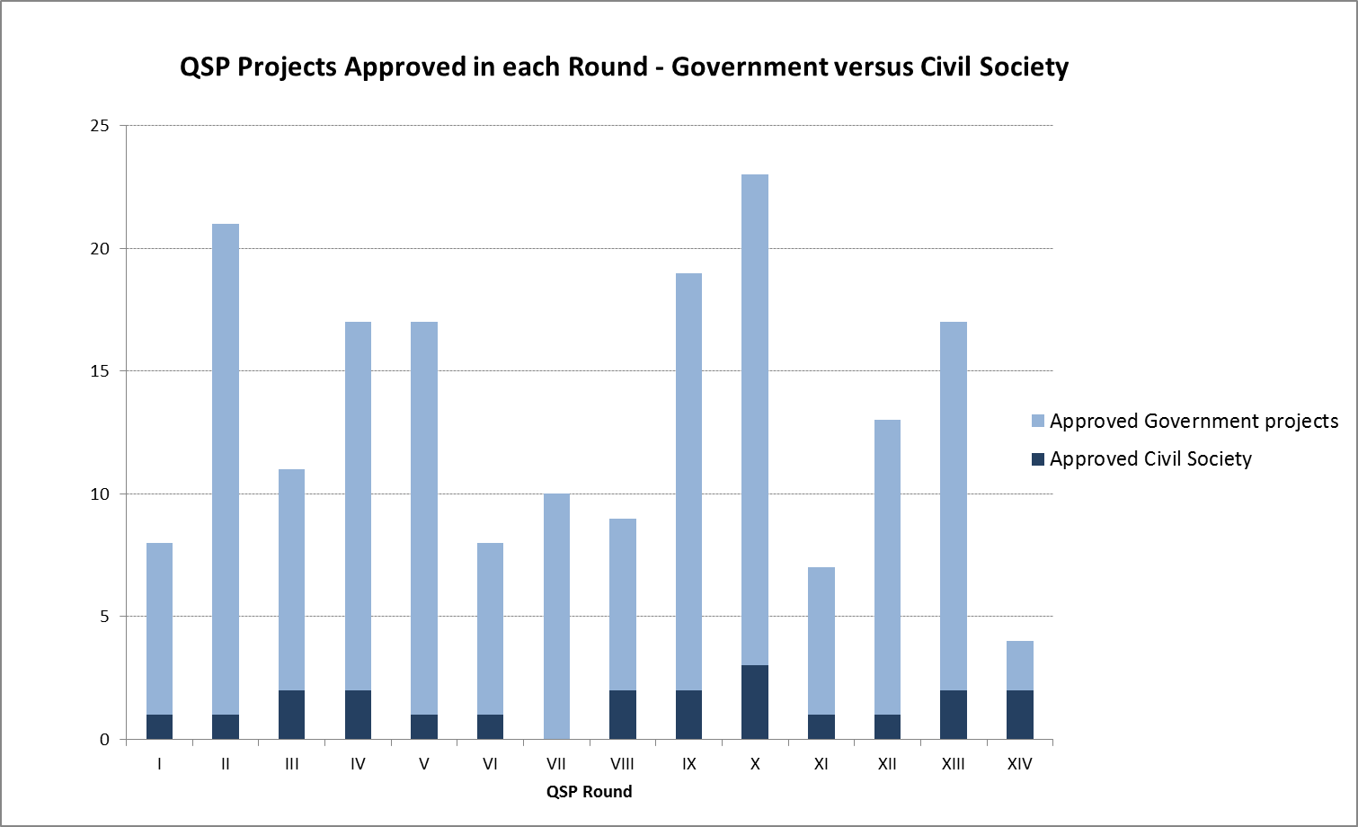

Figure 3. Approved Government and Civil Society projects (% of total number of projects)

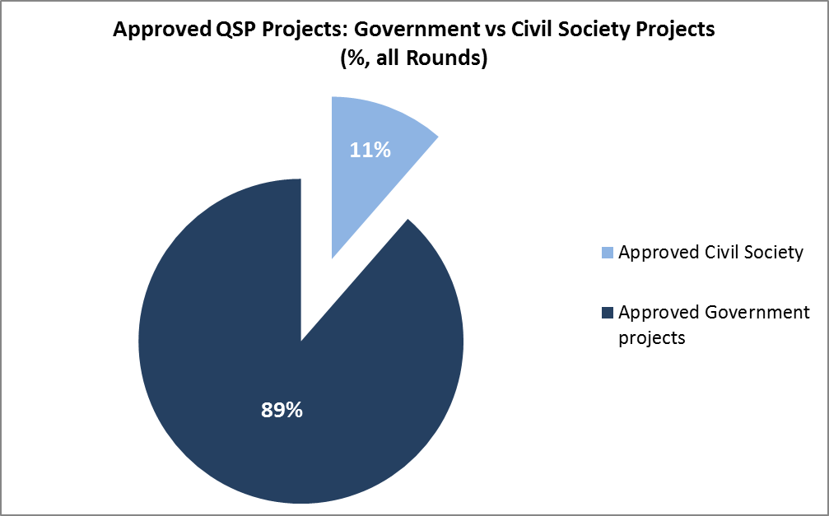

Figure 4. Sectoral balance of QSP projects: Number of approved QSP projects addressing each priority sector

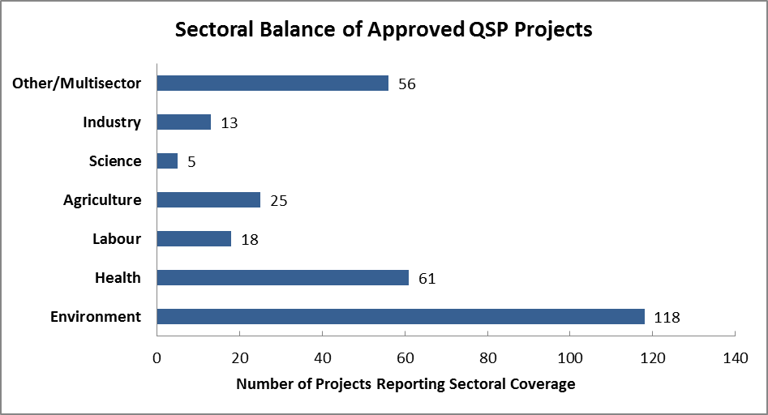

Figure 5. Sectoral balance of QSP projects: Number of approved QSP projects addressing each priority sector

Figure 6. Regional distribution of approved QSP projects by round

Figure 7. Regional distribution of approved projects

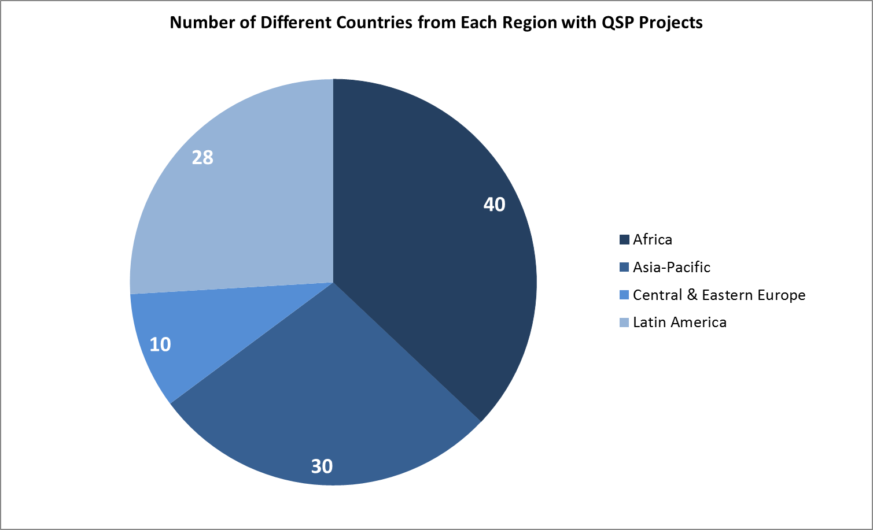

Figure 8. Distribution of approved QSP projects in relation to the three strategic priorities of the QSP – Total number of projects

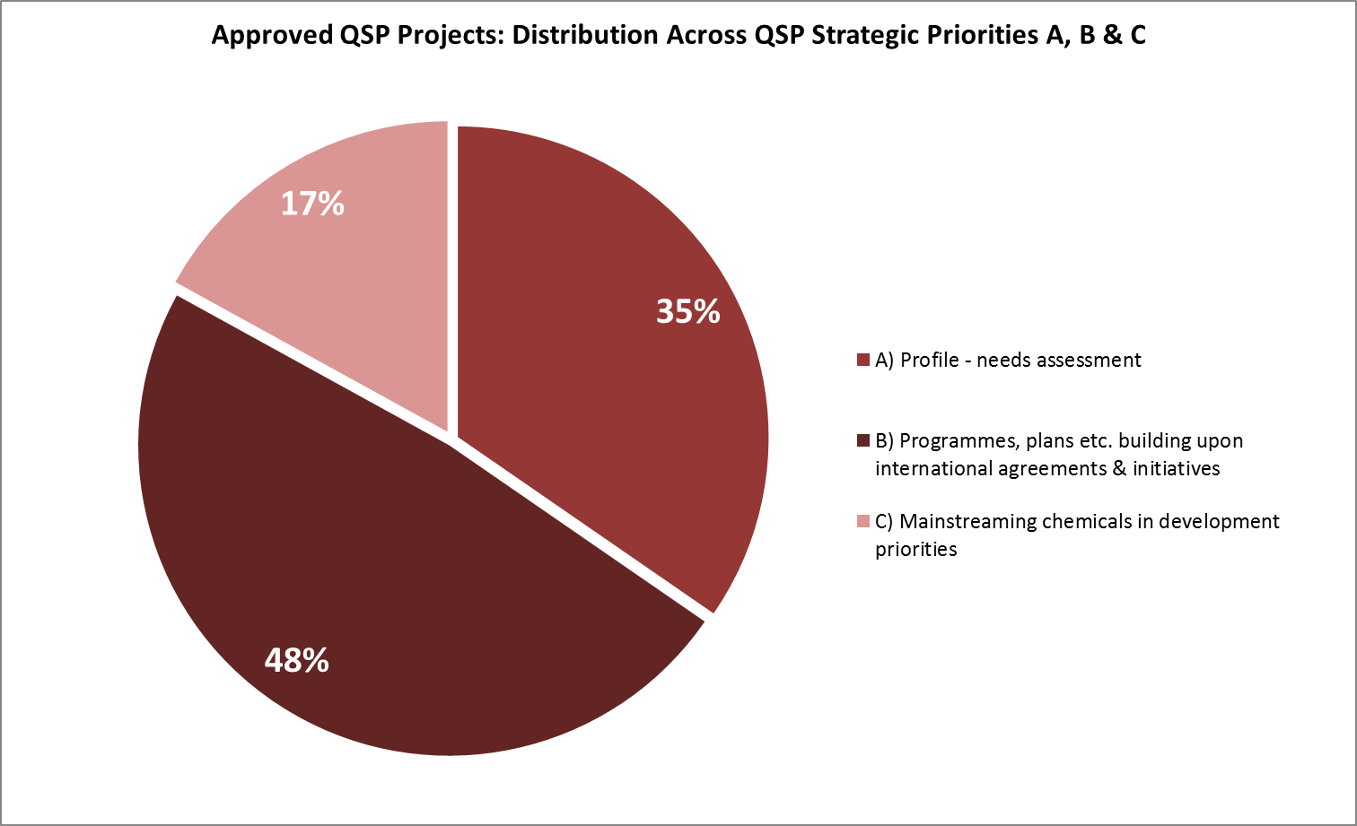

Figure 9. Number of approved QSP projects addressing each strategic priority per round

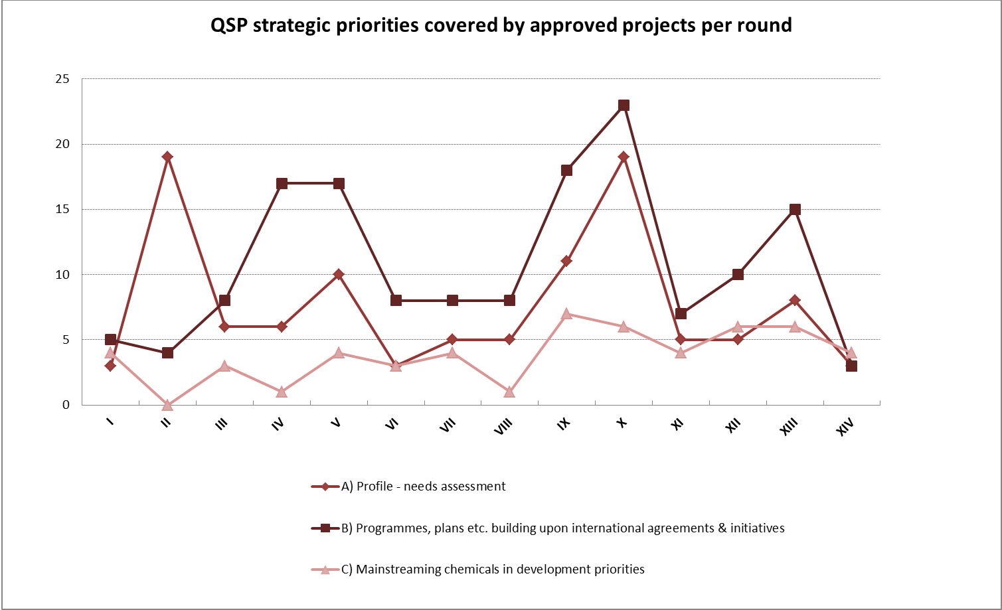

Figure 10. Funding granted and additional contributions leveraged for approved QSP projects

Figures 11 & 12. QSP projects with UN as Executing Agencies: by number and value

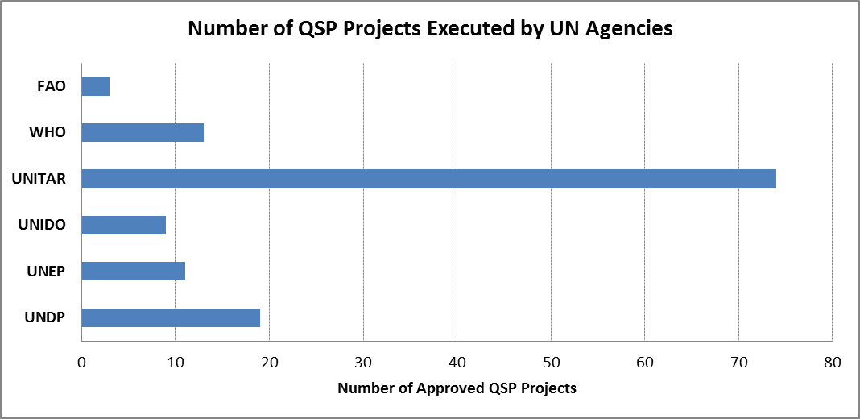

Figure 13. Infographic QSP overview

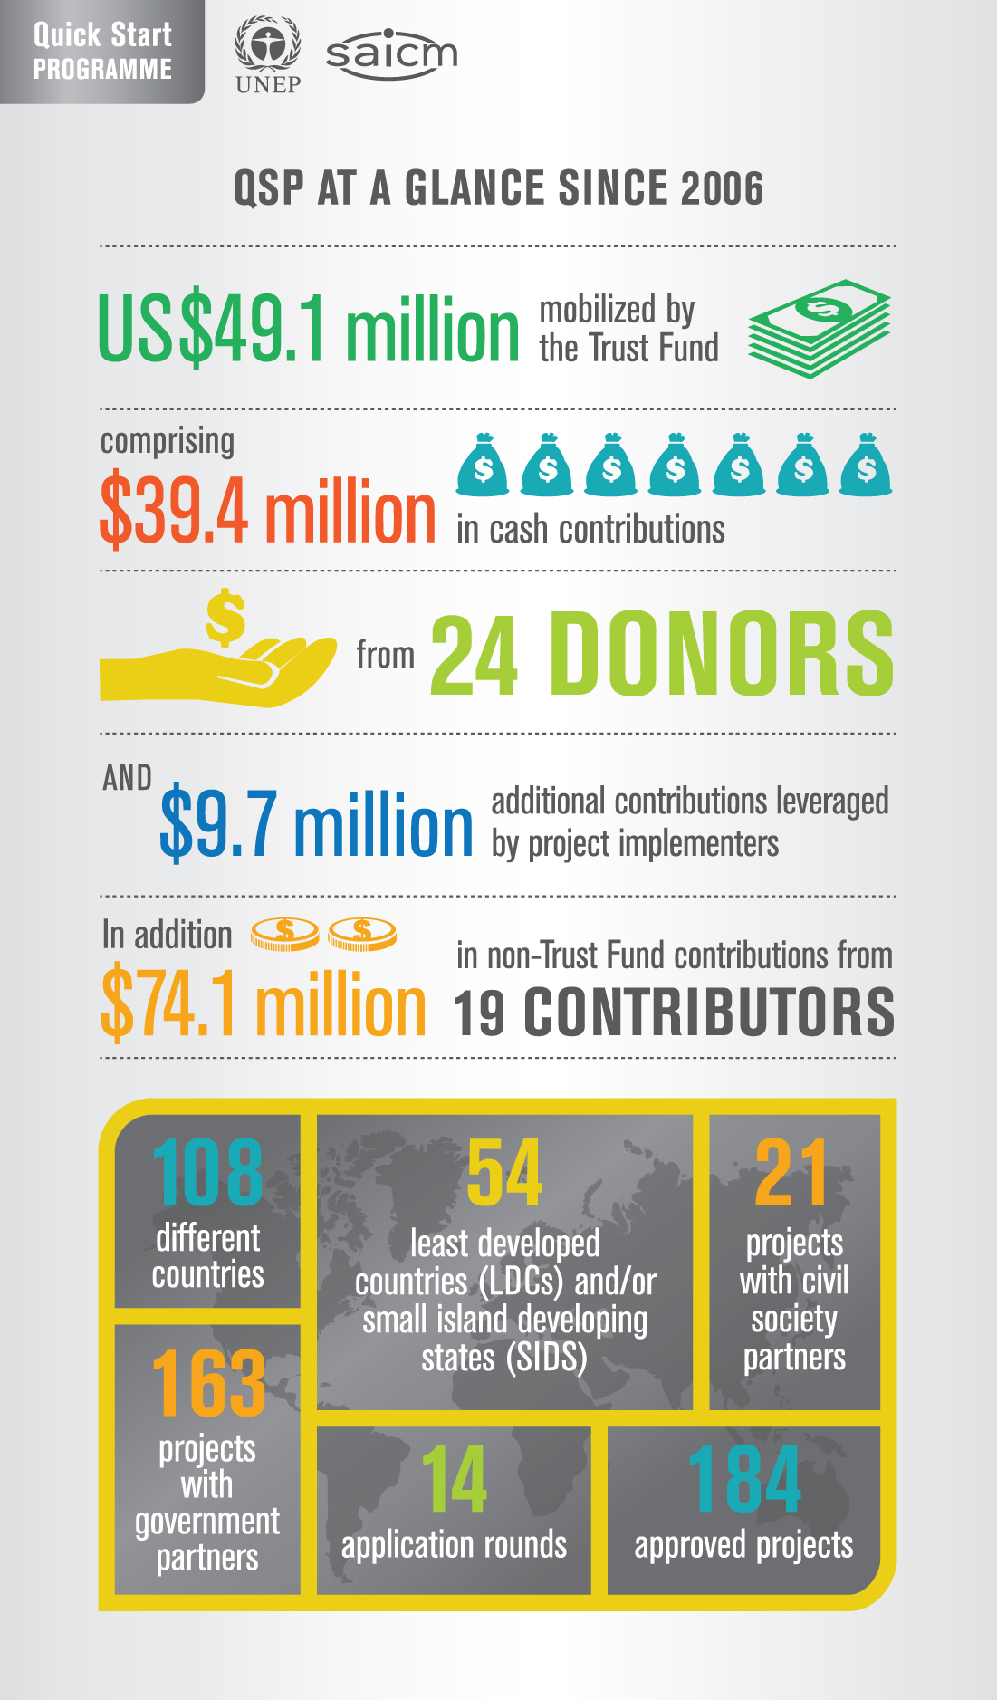

Figure 14. Infographic Additional funding leveraged by QSP projects

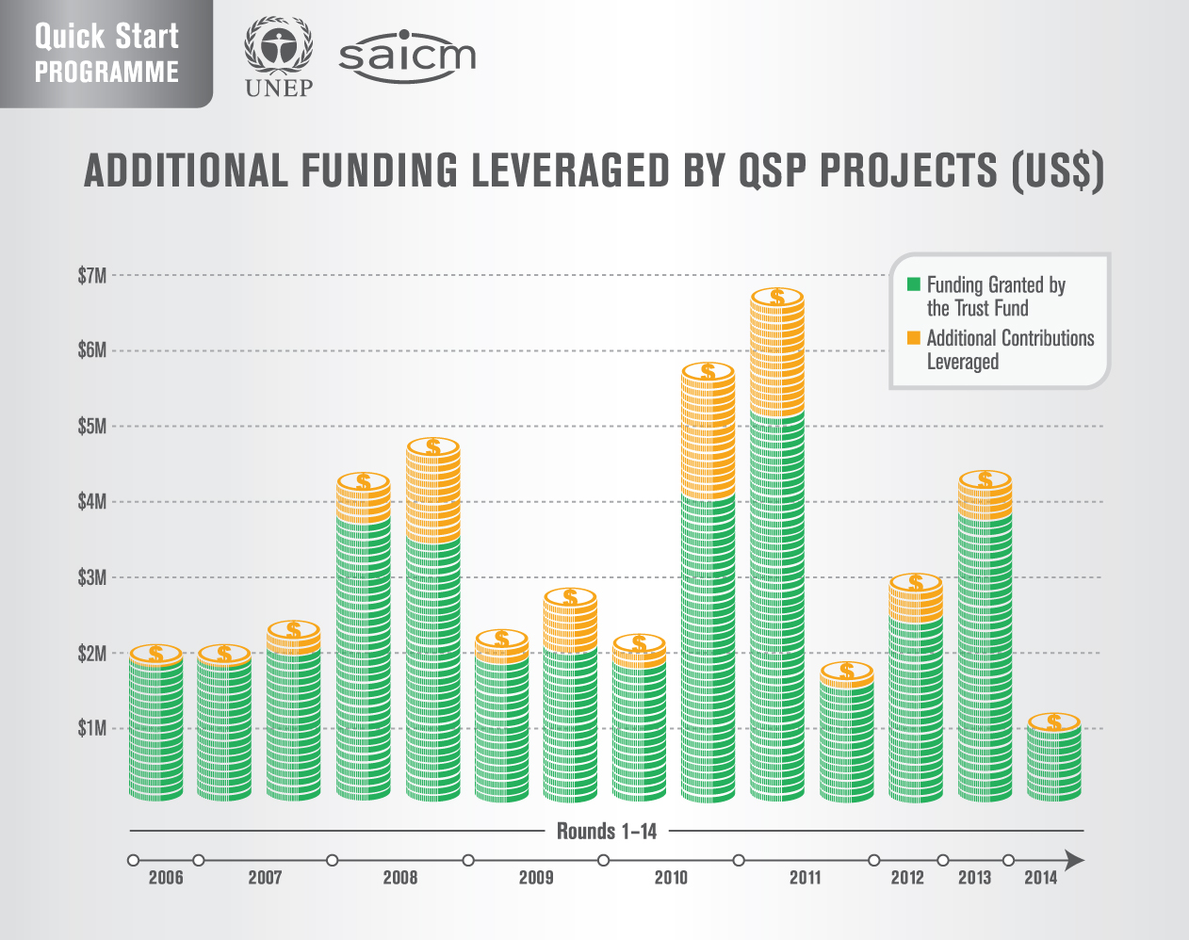

Figure 15. Infographic QSP projects by region

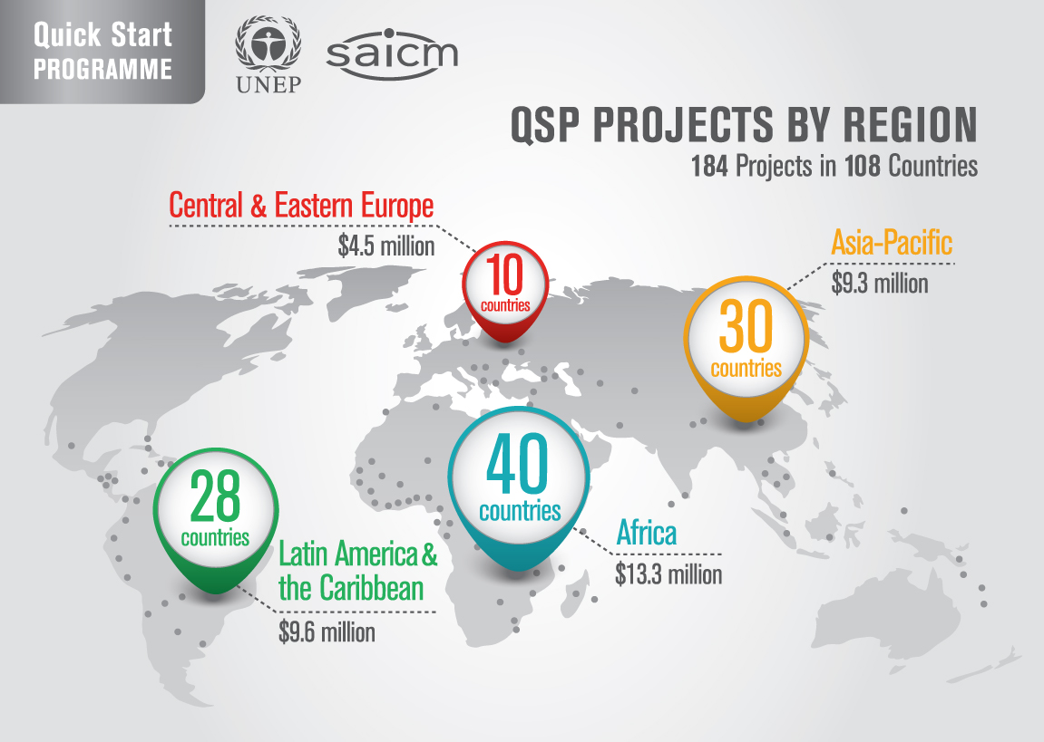

Figure 16. Infographic QSP projects by sector

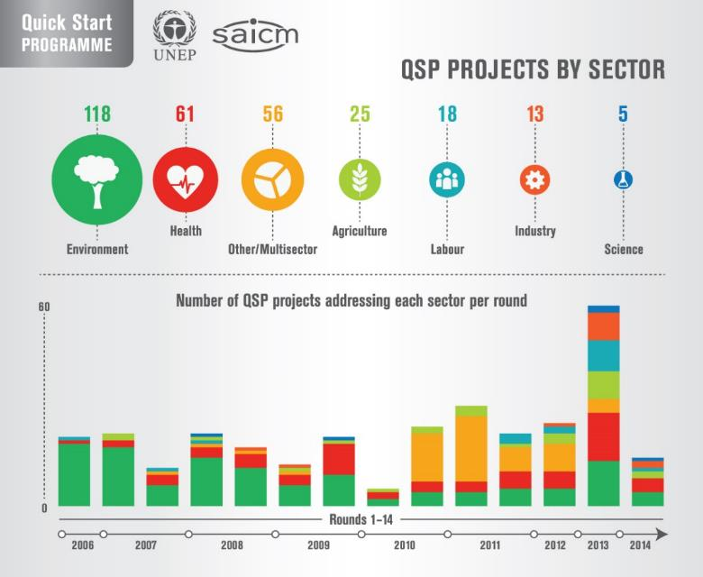

Figure 17. Infographic QSP projects by strategic priority

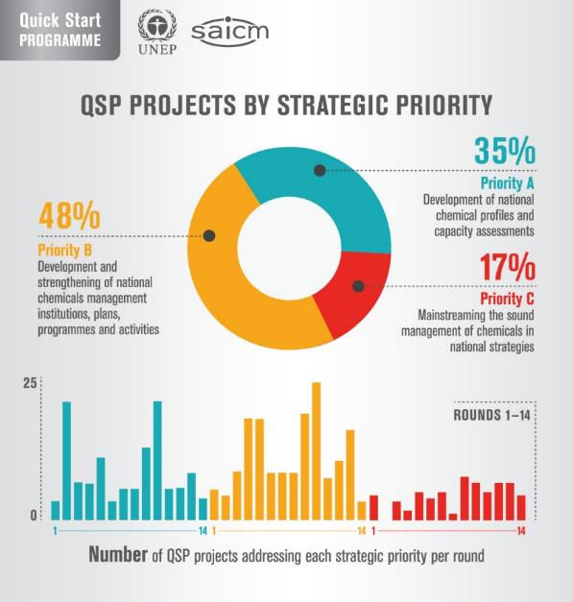

Figure 18. Infographic QSP project funding for LDCs and SIDS

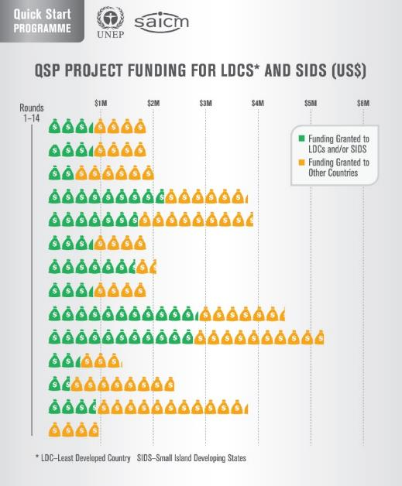

Annex B – Summary of QSP projects and eligibility for support from the SAICM Quick Start Programme Trust Fund (round 1 to 14)

Countries / Territories | Developing countries (146) on OECD DAC list* | LDC (48)/SIDS (39) | SAICM National Focal Point nominated (177) | Eligible for QSP Trust Fund | Approved QSP TF projects as of October 2017
 |  |  |  |  | Total Projects | Government | Civil Society
Afghanistan | DAC: LDC | LDC |  | Yes |  | none | none
Albania | DAC: UM |  |  | Yes | 3 | one | two (2mc)
Algeria | DAC: UM |  |  | Yes |  | none | none
Andorra |  |  |  | No
Angola | DAC: LDC | LDC |  | Yes |  | none | none
Antigua and Barbuda | DAC: UM | SIDS |  | Yes |  | none | none
Argentina | DAC: UM |  |  | Yes | 2 | none | two (mc)
Armenia | DAC: LM |  |  | Yes | 4 | four (2mc) | none
Australia |  |  |  | No
Austria |  |  |  | No
Azerbaijan | DAC: UM |  |  | Yes | 1 | one | none
Bahamas |  | SIDS |  | Yes | 2 | two (1mc/s) | none
Bahrain |  | SIDS |  | Yes | 1 | one | none
Bangladesh | DAC: LDC | LDC |  | Yes |  | none | none
Barbados |  | SIDS |  | Yes | 4 | four (1mc/s) | none
Belarus | DAC: UM |  |  | Yes | 5 | four (1s) | one
Belgium |  |  |  | No
Belize | DAC: UM | SIDS |  | Yes | 2 | two | none
Benin | DAC: LDC | LDC |  | Yes | 1 | one | none
Bhutan | DAC: LDC | LDC |  | Yes | 1 | one | none
Bolivia | DAC: LM |  |  | Yes | 4 | three (1mc) | one (mc)
Bosnia and Herzegovina | DAC: UM |  |  | Yes | 1 | none | one (mc)
Botswana | DAC: UM |  |  | Yes |  | none | none
Brazil | DAC: UM |  |  | Yes | 1 | none | one (mc)
Brunei |  |  |  | No
Bulgaria |  |  |  | No
Burkina Faso | DAC: LDC | LDC |  | Yes | 3 | three (1mc, 1mc/s) | none
Burundi | DAC: LDC | LDC |  | Yes | 3 | three (1mc) | none
Cabo Verde | DAC: LM | SIDS |  | No
Cambodia | DAC: LDC | LDC |  | Yes | 4 | four (2mc) | none
Cameroon | DAC: LM |  |  | Yes | 2 | one | one
Canada |  |  |  | No
Central African Republic | DAC: LDC | LDC |  | Yes |  | none | none
Chad | DAC: LDC | LDC |  | Yes | 2 | two (1mc/s) | none
Chile | DAC: UM |  |  | Yes | 5 | three (2mc) | two (2mc)
China | DAC: UM |  |  | Yes | 1 | one | none
Colombia | DAC: UM |  |  | Yes | 2 | two | none
Comoros | DAC: LDC | LDC-SIDS |  | Yes | 2 | two | none
Congo, Republic of the | DAC: LM |  |  | Yes | 2 | two (1mc) | none
Cook Islands | DAC: UM | SIDS |  | Yes | 2 | two (2mc) | none
Costa Rica | DAC: UM |  |  | Yes | 3 | two (1mc) | one
Côte d'Ivoire | DAC: LM |  |  | Yes | 3 | three (1mc) | none
Croatia |  |  |  | No
Cuba | DAC: UM | SIDS |  | Yes | 1 | one | none
Cyprus |  |  |  | No
Czech Republic |  |  |  | No
Democratic People's Republic of Korea | DAC: OL |  |  | Yes | 2 | two | none
Democratic Republic of the Congo | DAC: LDC | LDC |  | Yes | 1 | one | none
Denmark |  |  |  | No
Djibouti | DAC: LDC | LDC |  | Yes | 3 | three (1s) | none
Dominica | DAC: UM | SIDS |  | Yes |  | none | none
Dominican Republic | DAC: UM | SIDS |  | Yes | 2 | one | one (mc)
Ecuador | DAC: UM |  |  | Yes | 1 | one | none
Egypt | DAC: LM |  |  | Yes | 2 | one | one
El Salvador | DAC: LM |  |  | Yes | 3 | two | one (mc)
Equatorial Guinea | DAC: LDC | LDC |  | No
Eritrea | DAC: LDC | LDC |  | Yes | 1 | one | none
Estonia |  |  |  | No
Ethiopia | DAC: LDC | LDC |  | Yes | 2 | two | none
Fiji | DAC: UM | SIDS |  | Yes |  | none | none
Finland |  |  |  | No
France |  |  |  | No
Gabon | DAC: UM |  |  | Yes | 2 | two (1mc) | none
Gambia | DAC: LDC | LDC |  | Yes | 2 | two (1mc/s) | none
Georgia | DAC: LM |  |  | Yes | 3 | two (1mc) | one
Germany |  |  |  | No
Ghana | DAC: LM |  |  | Yes | 3 | three (1mc) | none
Greece |  |  |  | No
Grenada | DAC: UM | SIDS |  | No
Guatemala | DAC: LM |  |  | Yes | 2 | two | none
Guinea | DAC: LDC | LDC |  | Yes | 2 | two | none
Guinea-Bissau | DAC: LDC | LDC-SIDS |  | Yes |  | none | none
Guyana | DAC: LM | SIDS |  | Yes | 1 | one | none
Haiti | DAC: LDC | LDC-SIDS |  | Yes | 3 | three (1mc, 1mc/s) | none
Honduras | DAC: LM |  |  | Yes | 4 | four (2mc) | none
Hungary |  |  |  | No
Iceland |  |  |  | No
India | DAC: LM |  |  | Yes |  | none | none
Indonesia | DAC: LM |  |  | Yes | 2 | two (1mc) | none
Iran | DAC: UM |  |  | Yes |  | none | none
Iraq | DAC: UM |  |  | Yes |  | none | none
Ireland |  |  |  | No
Israel |  |  |  | No
Italy |  |  |  | No
Jamaica | DAC: UM | SIDS |  | Yes | 2 | two | none
Japan |  |  |  | No
Jordan | DAC: UM |  |  | Yes | 1 | one | none
Kazakhstan | DAC: UM |  |  | Yes | 3 | two | one (mc)
Kenya | DAC: OL |  |  | Yes | 3 | two (1mc) | one (mc)
Kiribati | DAC: LDC | LDC-SIDS |  | Yes | 4 | four (2mc) | none
Kosovo | DAC: LM |  |  | No
Kuwait |  |  |  | No
Kyrgyz Republic | DAC: LM |  |  | Yes | 4 | three | one (mc)
Lao PDR | DAC: LDC | LDC |  | Yes | 3 | two (1s, 1mc) | one
Latvia |  |  |  | No
Lebanon | DAC: UM |  |  | Yes |  | none | none
Lesotho | DAC: LDC | LDC |  | Yes | 2 | two | none
Liberia | DAC: LDC | LDC |  | Yes | 2 | two | none
Libya | DAC: UM |  |  | Yes |  | none | none
Liechtenstein |  |  |  | No
Lithuania |  |  |  | No
Luxembourg |  |  |  | No
Macedonia, Former Yugoslav Republic of | DAC: UM |  |  | Yes | 3 | two (1mc) | one (mc)
Madagascar | DAC: LDC | LDC |  | Yes | 3 | three (1mc) | none
Malawi | DAC: LDC | LDC |  | Yes | 1 | one | none
Malaysia | DAC: UM |  |  | Yes | 1 | one | none
Maldives | DAC: UM | SIDS |  | Yes | 1 | one | none
Mali | DAC: LDC | LDC |  | Yes | 5 | four | one (mc)
Malta |  |  |  | No
Marshall Islands | DAC: UM | SIDS |  | Yes |  | none | none
Mauritania | DAC: LDC | LDC |  | Yes | 2 | two (1mc/s) | none
Mauritius | DAC: UM | SIDS |  | Yes | 1 | one | none
Mexico | DAC: UM |  |  | Yes | 1 | one | none
Micronesia, Federated States of | DAC: LM | SIDS |  | No
Moldova | DAC: LM |  |  | Yes | 4 | three (1mc) | one
Monaco |  |  |  | No
Mongolia | DAC: LM |  |  | Yes | 3 | three (1mc) | none
Montenegro | DAC: UM |  |  | No
Montserrat | DAC: UM |  |  | No
Morocco | DAC: LM |  |  | Yes | 1 | one | none
Mozambique | DAC: LDC | LDC |  | Yes | 2 | two | none
Myanmar | DAC: LDC | LDC |  | Yes |  | none | none
Namibia | DAC: UM |  |  | No
Nauru | DAC: UM | SIDS |  | Yes |  | none | none
Nepal, Republic of | DAC: LDC | LDC |  | Yes | 2 | one | one
Netherlands |  |  |  | No
New Zealand |  |  |  | No
Nicaragua | DAC: LM |  |  | Yes | 4 | three (2mc) | one (mc)
Niger | DAC: LDC | LDC |  | Yes | 2 | two (1mc/s) | none
Nigeria | DAC: LM |  |  | Yes | 1 | one | none
Niue | DAC: UM |  |  | No
Norway |  |  |  | No
Oman |  |  |  | Yes |  | none | none
Pakistan | DAC: LM |  |  | Yes | 1 | one (mc) | none
Palau | DAC: UM | SIDS |  | Yes | 1 | one | none
Palestine | DAC: LM |  |  | Yes | 1 | one (s) | none
Panama | DAC: UM |  |  | Yes | 1 | one | none
Papua New Guinea | DAC: LM | SIDS |  | Yes |  | none | none
Paraguay | DAC: LM |  |  | Yes | 3 | two | one (mc)
Peru | DAC: UM |  |  | Yes | 3 | two (1mc) | one (mc)
Philippines | DAC: LM |  |  | Yes | 3 | two (1mc) | one (mc)
Poland |  |  |  | No
Portugal |  |  |  | No
Qatar |  |  |  | No
Republic of Korea |  |  |  | No
Romania |  |  |  | No
Russian Federation |  |  |  | No
Rwanda | DAC: LDC | LDC |  | Yes | 2 | two (2mc) | none
Saint Helena | DAC: UM |  |  | No
Saint Kitts and Nevis |  | SIDS |  | No
Saint Lucia | DAC: UM | SIDS |  | Yes | 1 | one | none
Saint Vincent and the Grenadines | DAC: UM | SIDS |  | Yes | 1 | one | none
Samoa | DAC: LM | SIDS |  | Yes | 3 | three (2mc) | none
São Tomé and Principe | DAC: LDC | LDC-SIDS |  | Yes | 1 | one (mc) | none
Saudi Arabia |  |  |  | No
Senegal | DAC: LDC | LDC |  | Yes | 3 | two | one (mc)
Serbia | DAC: UM |  |  | Yes | 3 | three (1mc) | none
Seychelles | DAC: UM | SIDS |  | Yes | 1 | one | none
Sierra Leone | DAC: LDC | LDC |  | Yes |  | none | none
Singapore |  | SIDS |  | No
Slovakia |  |  |  | No
Slovenia |  |  |  | No
Solomon Islands | DAC: LDC | LDC-SIDS |  | Yes | 1 | one (mc) | none
Somalia | DAC: LDC | LDC |  | No
South Africa | DAC: UM |  |  | Yes |  | none | none
South Sudan | DAC: LDC | LDC |  | No
Spain |  |  |  | No
Sri Lanka | DAC: LM |  |  | Yes | 4 | four (1mc) | none
Sudan | DAC: LDC | LDC |  | Yes | 1 | one | none
Suriname | DAC: UM | SIDS |  | Yes | 1 | one | none
Swaziland | DAC: LM |  |  | Yes | 1 | one | none
Sweden |  |  |  | No
Switzerland |  |  |  | No
Syria | DAC: LM |  |  | Yes | 1 | one (mc) | none
Tajikistan | DAC: OL |  |  | Yes | 2 | two | none
Tanzania | DAC: LDC | LDC |  | Yes | 5 | two (1s) | three (1mc, 1s)
Thailand | DAC: UM |  |  | Yes | 3 | two (1mc) | one
Timor-Leste | DAC: LDC | LDC-SIDS |  | No
Togo | DAC: LDC | LDC |  | Yes | 1 | one | none
Tonga | DAC: UM | SIDS |  | Yes | 1 | one (mc) | none
Tokelau | DAC: LM |  |  | No
Trinidad and Tobago |  | SIDS |  | Yes | 1 | one | none
Tunisia | DAC:UM |  |  | Yes | 1 | one | none
Turkey | DAC: UM |  |  | Yes |  | none | none
Turkmenistan | DAC: UM |  |  | No
Tuvalu | DAC: LDC | LDC-SIDS |  | Yes |  | none | none
Uganda | DAC: LDC | LDC |  | Yes | 3 | one | two (1mc)
Ukraine | DAC: LM |  |  | Yes | 2 | two (1mc) | none
United Arab Emirates |  |  |  | No
United Kingdom |  |  |  | No
United States of America |  |  |  | No
Uruguay | DAC: UM |  |  | Yes | 4 | two | two (mc)
Uzbekistan | DAC: LM |  |  | Yes | 2 | two | none
Vanuatu | DAC: LDC | LDC-SIDS |  | Yes |  | none | none
Venezuela | DAC: UM |  |  | Yes |  | none | none
Vietnam | DAC: LM |  |  | Yes | 4 | four | none
Wallis & Futuna | DAC: UM |  |  | No
Yemen | DAC: LDC | LDC |  | Yes | 2 | two | none
Zambia | DAC: LDC | LDC |  | Yes | 2 | two | none
Zimbabwe | DAC: OL |  |  | Yes |  | none | none
Totals | 146 | 78 | 177 | 135 | 240

*Developing countries and countries with economies in transition listed on the OECD Development Assistance Committee (DAC) list of recipients Official Development Assistance (excluding "territories"),
LDC: Least Developed Countries
OL: Other Low Income Countries
LM: Lower Middle Income Countries & Territories
UM: Upper Middle Income Countries & Territories
SIDS: Small Island Developing States
(mc) = multi-country
(s) = suspended

No project approved in this category
Projects approved in this category
Not eligible
Eligible countries that have not yet received funds from QSP Trust Fund

NOTE: When appraising the applications, the QSP Trust Fund Implementation Committee uses the following criteria:
- it gives priority to countries which have not previously had support from the QSP trust fund;
- it takes into account whether there had been satisfactory reports on earlier projects involving countries for the second time;
- it seeks to avoid duplication of projects and ensure coverage of different QSP strategic priorities;
- it seeks to avoid an excessive allocation of resources to individual countries; and
- it observes the usual requirements for geographical and sectoral balance.

Annex C: Countries with more than one QSP project by region (71/108)

Country | Region | N° of projects | Rounds | Executing Agencies | Strategic Priorities
Burkina Faso | AFR | 3 | 1st (MC), 7th (MC), 10th | UNITAR, CLISS, UNITAR | A / B,C / B,C
Burundi | AFR | 3 | 2nd, 7th (MC), 12th | UNITAR, none, UNITAR | A / B / B
Cameroon | AFR | 2 | 8th (NGO), 9th | None, UNITAR | B / A,B
Chad | AFR | 2 | 2nd, 7th (MC) | UNITAR, CILSS | A,B / B,C
Comoros | AFR | 2 | 2nd, 10th | UNITAR, UNITAR | A / A,B
Congo (Republic of) | AFR | 2 | 1st (MC), 8th | UNITAR, UNITAR | A / A,B
Cote d’Ivoire | AFR | 3 | 1st(MC), 4th , 11th | UNITAR, Basel Convention Sec., UNIDO | A / B / A,B,C
Djibouti | AFR | 3 | 1st (MC), 6th (suspended), 13th | UNITAR, BCRC, UNEP | A / B,C / B
Egypt | AFR | 2 | 2nd (NGO), 5th | None, UNIDO | B / B
Ethiopia | AFR | 2 | 9th, 9th | BCRC, none | B / B
Gabon | AFR | 2 | 6th (MC), 8th | UNEP&WHO, UNITAR | B / A,B
Gambia | AFR | 2 | 6th, 7th | UNITAR, CLISS | A,B / B,C
Ghana | AFR | 3 | 2nd , 7^{th,} 12th | UNITAR, IPCP, WHO | A / B / A,B
Guinea | AFR | 2 | 7th, 13th | UNITAR, UNITAR | A,B / B
Kenya | AFR | 3 | 3rd, 5th (NGO), 6th | UNITAR, none, UNEP&WHO | A / B / B
Lesotho | AFR | 2 | 2nd, 13th | UNITAR, none | A / A,B
Liberia | AFR | 2 | 3rd, 5th | UNITAR, UNDP & UNEP | A / B,C
Madagascar | AFR | 3 | 1st (MC), 5th, 9th | UNITAR, WHO, UNITAR | A / A,B,C / A, B
Mali | AFR | 5 | 3rd, 6th (MC) , 9th (NG0), 9th (MC), 10th | UNITAR, none, UNIDO, PAN, UNITAR | A/ B /A,B,C/ B,C/A,B
Mauritania | AFR | 2 | 5th, 7th (MC) | UNDP&UNEP, CILSS | A,B,C / B,C
Mozambique | AFR | 2 | 9th, 9th | FAO, BCRC | B / B
Niger | AFR | 2 | 7th (MC), 8th | CILSS, UNITAR | B,C / A,B
Rwanda | AFR | 2 | 1st (MC), 7th | UNITAR, none | A / B
Senegal | AFR | 3 | 5th, 6th, 9th (NGO) | UNITAR, none, PAN | A,B / B / B,C
Tanzania | AFR | 5 | 1st (NGO, suspended), 4th (NGO), 4th (Suspended), 5th (NGO, MC), 11th | None, none, none, none, UNEP | B, C / B/ B / B / A, B, C
Uganda | AFR | 3 | 1st, 5th (NGO, MC), 9th (NGO) | UNDP&UNEP, none, UNDP | A / B / B,C
Zambia | AFR | 2 | 5th, 10th | UNITAR, WHO | A,B / A, B, C
Cambodia | ASP | 4 | 2nd, 4th, 8th, 8th (MC) | UNITAR, UNEP, none, BCRC | A / B / B / B
Cook Islands | ASP | 2 | 7th (MC), 11th (MC) | WHO, SPREP | B / A,B,C
Dem. People's Republic of Korea | ASP | 2 | 5th, 12th | UNITAR, UNITAR | A,B / B
Indonesia | ASP | 2 | 4th(MC), 9th | WHO, Blacksmith Institute | B / C
Kazakhstan | ASP | 3 | 2nd, 4th, 11th (NGO, MC) | UNITAR, UNITAR,UNDP | A / B / A,B,C
Kiribati | ASP | 4 | 2nd, 7th, 9th, 11th (MC) | UNITAR, WHO, SPREP | A / B / A,B / A,B,C
Kyrgyzstan | ASP | 4 | 2nd, 4th (NGO, MC), 6th, 10th | UNITAR, UNITAR, UNEP&UNDP, UNITAR | A, B / B,C / A,B
Lao PDR | ASP | 3 | 7th (suspended), 8th (MC), 12th (NGO) | UNDP, BCRC, SAEDA | B,C / B / C
Mongolia | ASP | 3 | 1st (MC), 13th, 13th | UNITAR, WHO, UNITAR | A / AB / B
Nepal | ASP | 2 | 2nd, 10th (NGO) | UNITAR, LEADERS | A / B
Philippines | ASP | 3 | 4th, 4th, 11th (MC, MC, MC) | None, UNEP, HCWH | A,B / B / B
Samoa | ASP | 3 | 4th, 7th, 11th (MC) | None, WHO, SPREP | A,B / B / A,B,C
Sri Lanka | ASP | 4 | 5th,8th (MC) 10th, 13th | WHO, BCRC, UNEP, UNIDO | A,B / B / B,C / A, B
Tajikistan | ASP | 2 | 9th, 10th | None, UNITAR | A,B,C / A, B
Thailand | ASP | 3 | 4th(MC), 5th, 6th | WHO, none, CRI | B / B / B
Uzbekistan | ASP | 2 | 5th, 13th | UNITAR, UNITAR | A,B / B
Vietnam | ASP | 4 | 9th, 10th, 12th, 13th | UNDP, none, UNDP, none | A,B,C / A,B / A,B,C / A, B
Yemen | ASP | 2 | 3rd, 13th | UNITAR, none | A,B / A,C
Albania | CEE | 3 | 6th, 14th (MC, NGO), 14th (NGO) | UNITAR, WECF, SECID | A,B/ ABC/ABC
Armenia | CEE | 4 | 1st(MC), 3rd, 7th (MC), 12th | UNITAR, none, IPCP, none | A / B,C / B /B,C
Belarus | CEE | 5 | 3rd (suspended), 4th (NGO), 9th, 12th, 13th (MC) | UNDP & UNEP, none, UNDP & UNEP, WHO | B,C / B / A,B,C / B,C / A,B,C
Georgia | CEE | 3 | 1st (MC), 4th, 8th(NGO) | UNITAR, UNITAR, none | A / B / B,C
Macedonia | CEE | 3 | 1st, 13th (MC), 14th (MC, NGO) | UNDP, none, WECF | B,C / B / A,B,C
Moldova | CEE | 4 | 2nd, 9th, 10th (NGO), 13th (MC) | None, UNITAR, UAP, none | A,B / A,B / B,C / B
Serbia | CEE | 3 | 1st (MC), 12th, 13th | UNITAR, UNDP, WHO | A / C / A,B,C
Ukraine | CEE | 2 | 13th, 13th (MC) | WHO, WHO | A,B,C / A,B,C
Argentina | LAC | 2 | 3rd (MC, NGO) , 11th (MC, NGO) | none, none | B/ B
Bahamas | LAC | 2 | 4th (MC), 12th | UNEP, WHO | B / A,B
Barbados | LAC | 4 | 2nd, 4th (MC) , 7^{th,} 13th | UNITAR, UNEP, UNITAR, none | A / B / A,B / B
Belize | LAC | 2 | 4th, 10th | UNDP & UNEP, UNEP | B,C / B
Bolivia | LAC | 4 | 2nd, 3rd (NGO, MC), 5th (MC), 10th | UNITAR, none, UNEP, UNITAR | A / B / B / A,B
Chile | LAC | 5 | 1st (MC), 3rd (NGO, MC), 3rd (NGO, MC), 7th, 9th | UNITAR, none, none, IPCP, UNITAR | A / B / B / B / A,B
Colombia | LAC | 2 | 5th, 10th | UNIDO, UNITAR | A,B / A,B
Costa Rica | LAC | 3 | 1st, 6th, 13th (NGO) | UNITAR, none, IRET | A / A,B,C / B,C
Dominan Republic | LAC | 2 | 8th, 10th (NGO, MC) | UNITAR, Sustainlabour | A,B / A,B,C
El Salvador | LAC | 3 | 3rd, 10th (NGO, MC), 14th | UNIDO, Sustainlabour, FAO | B / A,B,C / A,B,C
Guatemala | LAC | 2 | 2nd, 10th | UNITAR, UNITAR | A / A,B
Haiti | LAC | 3 | 1st(MC), 4th (MC), 9th | UNITAR, UNEP, UNITAR | A / B / A,B
Honduras | LAC | 4 | 2nd, 5^{th,} 12th (MC), 13th (MC) | UNITAR, UNDP & UNEP, UNDP, PAHO | A / B,C / A,B / B
Jamaica | LAC | 2 | 10th, 10th | None, UNITAR | A,B / A,B
Nicaragua | LAC | 4 | 2nd, 10th (NGO), 12th (MC), 13th (MC) | UNITAR, Sustainlabour, UNDP, PAHO | A / A,B,C / A,B / B
Paraguay | LAC | 3 | 3rd (NGO, MC), 4th, 12th | UNITAR, UNITAR, FAO | B / A,B / B
Peru | LAC | 3 | 3rd, 3rd (NGO, MC), 5th(MC) | UNIDO, none, UNEP | A,B / B / B
Uruguay | LAC | 4 | 3rd (NGO, MC), 3rd (NGO, MC), 4th, 12th | None, none, UNIDO, CCCB | B / B / B / A

MC- Multi Country
IPCP- International Panel on Chemical Pollution
PAN- Pesticide Action Network
CILSS- Comité Inter-Etate pour la Lutte contre la Sécheresse au Sahel
HCWH – Health Care Without Harm
IRET – Regional Institute for Research on Toxic Substances
WECF – Women in Europe for a Common Future
SECID – Southeast European Center for Surveillance and Control of Infectious Diseases (Albania)
CRI - Chulabhorn Research Institute (Thailand)
BCRC – Basel Convention Region al Centre
SPREP – Secretariat of the Pacific Regional Environment Programme
SAEDA – Sustainable Agriculture and Environment Association (Lao)

Annex D: Status of projects funded under the Quick Start Programme Trust Fund
A. Completed Projects
A.1 Closed Projects – final satisfactory reports received and projects closed (130 projects)
 | Round | Project No. | Recipients | Project title | Executing Agency (ies) | Strategic priorities |  | Date of Agreement | End date | Funding granted
 | 1st | QSPTF/ 06/1/GOV/25 I.01.M | Burkina Faso, Djibouti, Madagascar, Rwanda and Sao Tome & Principe | Updating National Chemicals Management Profile of a national SAICM capacity assessment and holding a national SAICM priority setting workshop in five least developed countries | UNITAR | A |  | 24-Apr-07 | Mar-09 | $249,731
 | 1st | QSPTF/ 06/1/GOV/26 I.02.M | Côte d'Ivoire, Haiti, Mongolia, Republic of Congo and Syria | Updating National Chemicals Management Profile, development of a National SAICM Capacity Assessment and holding a national SAICM priority setting workshop in one LDC and four developing countries | UNITAR | A |  | 24-Apr-07 | Mar-09 | $248,296
 | 1st | QSPTF/ 06/1/GOV/27 I.03.M | Armenia, Chile, Costa Rica, Georgia and Serbia | Updating National Chemicals Management Profile, development of a National SAICM Capacity Assessment and holding a national SAICM priority setting workshop in two least developing countries and three countries in transition | UNITAR | A |  | 24-Apr-07 | Mar-09 | $248,035
 | 1st | QSPTF/ 06/1/GOV/28 I.04.ECU | Ecuador | Ecuador, UNEP and UNDP Partnership initiative for the implementation of SAICM | UNDP & UNEP | B, C |  | 01-Feb-08 | May-13 | $250,000
 | 1st | QSPTF/ 06/1/GOV/13 I.07.G.UGA | Uganda | Uganda, UNEP and UNDP Partnership initiative for the implementation of SAICM | UNDP & UNEP | B, C |  | 01-Sep-07 | Jan-10 | $250,000
 | 1st | QSPTF/06/1/GOV/17 | The Former Yugoslav Republic (FYR) of Macedonia | Development and mainstreaming of the National Plan on SAICM implementation for the Former Yugoslav Republic of Macedonia | UNDP | B, C |  | 01-Oct-07 | Feb-10 | $248,400
 | 1st | QSPTF/ 06/1/GOV/29 I.06.G.NGA | Nigeria | Establishing and institutional framework and strengthening national capacity within and integrated national programme for the sound management of chemicals and implementation of the Strategic Approach in Nigeria | None | B |  | 01-Dec-07 | Jun-11 | $230,000
 | 2nd | QSPTF/07/2/GOV/05 II.17.G.NPL | Nepal | Developing a national chemicals management profile, developing a national SAICM capacity assessment, and holding a national SAICM priority setting workshop in Nepal | UNITAR | A |  | 01-Dec-07 | Dec 2009 | $70,501
 | 2nd | QSPTF/07 /2/GOV/22 II.01.G.BRG | Barbados | Updating a national chemicals management profile, developing a national SAICM capacity assessment, and holding a national SAICM priority setting workshop in Barbados | UNITAR | A |  | 30-Oct-07 | Oct-09 | $55,450
 | 2nd | QSPTF/07/2/GOV/16 II.02.G.BOL | Bolivia | Strengthening national governance for SAICM implementation: updating the national chemicals management profile, developing a national SAICM capacity assessment, and holding a national SAICM forum in Bolivia | UNITAR | A |  | 21-Dec-07 | Dec-09 | $69,550
 | 2nd | QSPTF/ 07/2/GOV/23 II.03.G.BDI | Burundi | Updating the National Chemicals Management Profile and developing a national chemicals database in Burundi | UNITAR | A |  | 10-Jan-08 | Dec-08 | $99,250
 | 2nd | QSPTF/ 07/2/GOV/11 II.04.G.KHM | Cambodia | Updating the national chemicals management profile, development of a national SAICM capacity assessment and holding a national SAICM priority setting workshop in Cambodia | UNITAR | A |  | 21-Dec-07 | Dec-09 | $50,570
 | 2nd | QSPTF/ 07/2/GOV/15 II.05.G.TCD | Chad | Strengthening integrated chemicals management for effective SAICM implementation in Chad | UNITAR | A, B |  | 01-Jan-08 | Dec-09 | $119,900
 | 2nd | QSPTF/ 07/2/GOV/07 II.06.G.COM | Comoros | Developing a national SAICM capacity assessment, holding a national SAICM priority setting workshop and updating a National Chemicals Management Profile in Comoros | UNITAR | A |  | 23-Oct-07 | Oct-09 | $52,900
 | 2nd | QSPTF/ 07/2/GOV/18 II.08.G.GHA | Ghana | Updating the national chemicals management profile, developing a national SAICM capacity assessment, and holding of a national SAICM priority setting workshop in Ghana | UNITAR | A |  | 01-Jan-08 | Dec-09 | $50,750
 | 2nd | QSPTF/ 07/2/GOV/21 II.09.G.GTM | Guatemala | Strengthening national governance for SAICM implementation: updating the national chemicals management profile, developing a national SAICM capacity assessment, and holding a national SAICM forum in Guatemala | UNITAR | A |  | 01-Jan-08 | Dec-09 | $85,750
 | 2nd | QSPTF/ 07/2/GOV/17 II.10.G.HND | Honduras | Strengthening national governance for SAICM implementation: updating the national chemicals management profile, developing a national SAICM capacity assessment, and holding a national SAICM forum in Honduras | UNITAR | A |  | 21-Dec-07 | Dec-09 | $85,000
 | 2nd | QSPTF/ 07/2/GOV/20 II.11.G.KAZ | Kazakhstan | Updating the national chemicals management profile, development of a national SAICM capacity assessment and holding a national SAICM priority setting workshop in Kazakhstan | UNITAR | A |  | 10-Jan-08 | Dec-09 | $50,300
 | 2nd | QSPTF/ 07/2/GOV/25 II.12.G.KIR | Kiribati | Updating the national chemicals management profile, development of a national SAICM capacity assessment and holding a national SAICM priority setting workshop in Kiribati | UNITAR | A |  | 23-Oct-07 | Oct-08 | $64,800
 | 2nd | QSPTF/ 07/2/GOV/14 II.13.G.KGZ | Kyrgyzstan | Updating the national chemicals management profile, development of a national SAICM capacity assessment and holding a national SAICM priority setting workshop in Kyrgyzstan | UNITAR | A |  | 10-Jan-08 | Dec-09 | $50,950
 | 2nd | QSPTF/ 07/2/GOV/08 II.14.G.LSO | Lesotho | Updating the national chemicals management profile, developing a national SAICM capacity assessment, and holding of a national SAICM priority setting workshop in Lesotho | UNITAR | A |  | 01-Oct-07 | Oct-09 | $54,950
 | 2nd | QSPTF/ 07/2/GOV/06 II.15.G.MWI | Malawi | Updating the national chemicals management profile, developing a national SAICM capacity assessment, and holding of a national SAICM priority setting workshop in Malawi | UNITAR | A |  | 10-Dec-07 | Dec-09 | $50,576
 | 2nd | QSPTF/ 07/2/GOV/09 II.16.G.MDA | Moldova | Moldova and UNEP partnership on capacity building for improving the environmentally sound management of chemicals in the Republic of Moldova and the implementation of SAICM | none | A, B |  | 16-Jan-08 | Dec-09 | $249,950
 | 2nd | QSPTF/ 07/2/GOV/30 II.18.G.NIC | Nicaragua | Strengthening national governance for SAICM implementation: updating the national chemicals management profile, developing a national SAICM capacity assessment, and holding a national SAICM forum in Nicaragua | UNITAR | A |  | 01-Jan-08 | Dec-09 | $70,500
 | 2nd | QSPTF/07/2/GOV/13 II.20.G.TTO | Trinidad and Tobago | Strengthening the legislative, regulatory and enforcement capacity of SIDS in the Caribbean | Secretariat of the Basel Convention | B |  | 01-Nov-08 | Apr-10 | $178,794
 | 2nd | QSPTF/ 07/2/NGO/05 II.21.C.DHIDR | Day Hospital Institute for Development and Rehabilitation of Egypt | National awareness campaign for all stakeholders on the safe use and management of pesticides according to the International Code of Conduct on the Distribution and Use of Pesticides | none | B |  | 19-Dec-07 | Dec-09 | $199,000
 | 3rd | QSPTF/ 07/3/GOV/14 III.06.G.MLI | Mali | Updating the national chemicals management profile, developing a national SAICM capacity assessment, and holding a national SAICM priority setting workshop in Mali | UNITAR | A |  | 23-Apr-08 | Apr-10 | $58,400
 | 3rd | QSPTF/ 07/3/GOV/01 III.08.G.SDN | Sudan | Development of a Sustainable Integrated National Programme for Sound Management of Chemicals | UNIDO | A, B |  | 01-Apr-09 | Apr-11 | $144,072
 | 3rd | QSPTF/ 07/3/GOV/07 III.01.G.ARM | Armenia | Armenia and UNEP Partnership Initiative for Sound Management of Chemicals and Implementation of SAICM in Armenia | none | B, C |  | 31-Oct-08 | Sep-10 | $245,680
 | 3rd | QSPTF/07/3/NGO/01 III.10.C.AAMMA | Argentine Society of Doctors for the Environment (AAMMA) - Argentina, Bolivia, Chile, Paraguay, Peru and Uruguay | Integrated regional campaign on minimization of mercury domestic sources with actions of intervention in the community to protect children and women’s health | none | B |  | 01-Jun-08 | May-10 | $240,625
 | 3rd | QSPTF/ 07/3/NGO/03 III.11.C.SLAB | Sustainlabour - Brazil, Chile and Uruguay | Enabling workers and workplaces for SAICM implementation | none | B |  | 13-Oct-08 | Sep-10 | $227,224
 | 3rd | QSPTF/ 07/3/GOV/13 III.05.G.LBR | Liberia | Developing a National Chemicals Management Profile, developing a national SAICM capacity assessment and holding a national SAICM priority setting workshop in Liberia | UNITAR | A |  | 01-Oct-08 | Oct-10 | $71,050
 | 3rd | QSPTF/ 07/3/GOV/05 III.09.G.YEM | Yemen | Integrated national program for the sound management of chemicals and implementation of the Strategic Approach in Yemen | UNITAR | A, B |  | 01-Apr-08 | Apr-10 | $249,500
 | 3rd | QSPTF/ 07/3/GOV/11 III.04.G.KEN | Kenya | Strengthening Capacities in Kenya for National SAICM Implementation | UNITAR | A |  | 01-Jan-09 | Oct 2010 extension until 31 Oct 2011 | $249,900
 | 3rd | QSPTF/ 07/3/GOV/03 III.03.G.SLV | El Salvador | Life cycle Analysis of Chemical Substances | UNIDO | B, C |  | 03-Apr-09 | Apr 2011/ 30 Nov 2013 | $246,700
 | 3rd | QSPTF/ 07/3/GOV/07 III.07.G.PER | Peru | Safe Chemicals | UNIDO | A, B, C |  | 11-Jun-09 | Jun-11 | $249,004
 | 4th | QSPTF/ 08/4/GOV/14 IV.10.G.PLW | Palau | Establishing an institutional framework and strengthening national capacity for the sound chemicals management and implementation of the Strategic Approach in the Republic of Palau | none | A, B |  | Dec 2008 | Nov 2011 | $250,000
 | 4th | QSPTF/08/4/GOV/04 IV.12.G.PHL | Philippines | Development of an effective national chemical safety program towards chemical poisoning prevention and control | none | A, B |  | 01-Apr-09 | May-12 | $250,000
 | 4th | QSPTF/ 08/4/GOV/28 IV.15.G.URY | Uruguay | Sound Management for Mercury Products | UNIDO | B |  | 1-Feb-10 | Feb-12 | $249,800
 | 4th | QSPTF/ 08/4/GOV/15 IV.06.G.CIV | Côte d'Ivoire | Strengthening the capacity of Côte d’Ivoire to control the transboundary movements of hazardous wastes and chemicals in the context of the Basel Convention, the International Health Regulations (WHO, 2005) and other relevant MEAs as necessary, and ensure their environmentally sound management | Secretariat of the Basel Convention | B |  | 01-Oct-08 | Oct-11 | $249,930
 | 4th | QSPTF/ 08/4/GOV/ | Cambodia & Philippines | Protecting human health and the environment from mercury in artisanal and small scale gold mining (ASGM) in Asia | UNEP | B |  | N/A (project started in June 09) | Nov-10 | $250,000
 | 4th | QSPTF/ 08/4/NGO/06 IV.17.C.SETAC | Society of Environmental Toxicology and Chemistry (SETAC) | Scientific Capacity Building in Support of SAICM in Africa | none | B |  | 01-Oct-08 | Oct-09 | $250,000
 | 4th | QSPTF/ 08/4/GOV/12 IV.09.G.GUY | Guyana | Developing an Integrated National Programme for the Sound Management of Chemicals and SAICM Implementation in Guyana | UNITAR | A, B |  | 01-Jan-09 | Dec-10 | $90,000
 | 4th | QSPTF/ 08/4/GOV/16 IV.08.G.GEO | Georgia | Strengthening Capacities for Developing a National Pollutant and Release Transfer Register and Supporting SAICM Implementation in Georgia | UNITAR | B |  | 01-Mar-09 | Apr-11 | $170,500
 | 4th | QSPTF/ 08/4/NGO/08 IV.16.C.CEEAP NGOs | Network for Protection of Public Environmental Interests in the Kyrgyz Republic, Green Partnership & Local Self-Government Development Centre (CEEAP NGOs) | Strengthening Capacities of Civil Society Organizations for National and Regional SAICM Implementation in the Eastern Europe, Caucuses and Central Asia region | UNITAR | B |  | 01-Apr-09 | Apr-11 | $160,000
 | 4th | QSPTF/ 08/4/GOV/22 IV.07.G.CUB | Cuba | Capacity building for POPs laboratories in Cuba under multilateral environmental agreements | UNEP | B |  | 01-Oct-08 | Apr-10 | $250,000
 | 4th | QSPTF/ 08/4/GOV/7 IV.04.G.BHR | Bahrain | Capacity Building for Integrated and Sustainable Chemicals and Hazardous Waste Management | UNITAR | A, B |  | 15-May-09 | May-11 | $250,000
 | 4th | QSPTF/ 08/4/GOV/27 IV.05.G.BLZ | Belize | Mainstreaming into Developing Plans the Sound Management of Chemicals (SMC) Priorities for Key Development Sectors in Belize and Associated SMC Governance | UNDP & UNEP | B, C |  | 01-Oct-09 | Feb-11 | $250,000
 | 4th | QSPTF/ 08/4/GOV/08 IV.13.G.WSM | Samoa | Establishing an Institutional Framework and strengthening National Capacity within an integrated national programme for the sound management of chemicals and implementation of the Strategic Approach in Samoa | none | A, B |  | 01-Nov-08 | Nov-11 | $250,000
 | 4th | QSPTF/ 08/4/GOV/10 IV.03.M | Indonesia & Thailand | Technical Support to Strengthening National Capacities for Sound Management of Priority Industrial Carcinogens in Indonesia and Thailand | WHO | B |  | 7-Dec-09 | Dec-12 | $219,456
 | 5th | QSPTF/ 08/5/GOV/11 V.13.G.LKA | Sri Lanka | Strengthening National Capacities for Sound Management of Priority Industrial Carcinogens and Updating National Chemicals Profile in Sri Lanka | WHO | A, B | 7-Dec-09 |  | 6-Dec-12 | $232,539
 | 5th | QSPTF/ 08/5/GOV/20 V.12.G.SYC | Seychelles | Developing an Integrated National Programme for the Sound Management of Chemicals and SAICM Implementation in Seychelles | UNITAR | A, B |  | 26-Jan-10 | Jan-13 | $250,000
 | 5th | QSPTF/ 08/5/GOV/08 V.15.G.UZB | Uzbekistan | Developing an Integrated National Programme for the Sound Management of Chemicals and SAICM Implementation in Uzbekistan | UNITAR | A, B |  | 26-Jan-10 | Jan-13 | $250,000
 | 5th | QSPTF/ 08/5/NGO/04 V.17.C.EAF NGO | AGENDA, iLima-Kenya & NAPE | SAICM implementation is East Africa: Law reform and capacity building for sound chemicals management in Kenya, Tanzania and Uganda | none | B |  | 20-Mar-09 | Mar-11 | $250,000
 | 5th | QSPTF/ 08/5/GOV/10 V.08.G.MRT | Mauritania | Mauritania, UNDP and UNEP Partnership Initiative for the Integration of Sound Management of Chemicals Considerations into Development Plans and Processes | UNDP-UNEP | A, B, C |  | 07-Oct-09 | Apr-11 | $250,000
 | 5th | QSPTF/ 08/5/GOV/14 V.16.G.ZMB | Zambia | Strengthening Capacities for SAICM Implementation and Supporting GHS Capacity Building in Zambia | UNITAR | A, B |  | 26-Jan-10 | 25 Jan 2012 | $250,000
 | 5th | QSPTF/ 08/5/GOV/02 V.03.G.PRK | DPR Korea | Strengthening Capacities for National SAICM Implementation in the Democratic People’s Republic of Korea | UNITAR | A, B |  | 01-Apr-09 | Apr-11 | $244,750
 | 5th | QSPTF/ 08/5/GOV/22 V.02.G.COL | Colombia | Strengthening National Governance for SAICM Implementation in Colombia | UNIDO | A, B |  | 28-May-10 | Extension to 30 Nov 2013 | $249,800
 | 5th | QSPTF/ 08/5/GOV/21 V.05.G.HND | Honduras | Honduras, UNDP, and UNEP Partnership Initiative for the Integration of Sound Management of Chemicals Considerations into Development Plans and Processes | UNDP-UNEP | B, C |  | 22-Jul-11 | Jul-13 | $250,000
 | 5th | QSPTF/ 08/5/GOV/09 V.09.G.MAR | Morocco | Strengthening national capacity for the safe management of public health pesticides in Morocco | WHO | A, B |  | 06-Nov-09 | Nov 2010 / Nov 2011 | $175,000
 | 5th | QSPTF/ 08/5/GOV/01 V.04.G.EGY | Egypt | Assessment and Capacity Building in Chemicals and Chemicals Waste Management in Egypt | UNIDO | B |  | 01-Jun-09 | Jun-11 | $250,000
 | 5th | QSPTF/08/5/GOV/16 | Liberia | Liberia, UNDP, and UNEP Partnership Initiative for the Integration of Sound Management of Chemicals Considerations into Development Plans and Processes | UNDP-UNEP | C |  | 27-Jan-10 | Jul-11 | $250,000
 | 5th | QSPTF/ 08/5/GOV/17 V.07.G.MDG | Madagascar | Recycling/disposal of Insecticide-Treated Nets, exploratory project | WHO | A, B, C |  | 06-Nov-09 | Jan 2011 /Nov 2011) | $250,000
 | 5th | QSPTF/ 08/5/GOV/19 V.11.G.SEN | Senegal | Strengthening National Capacities in Senegal for SAICM Implementation | UNITAR | A, B |  | 26-Jan-10 | Jan-12 | $250,000
 | 5th | QSPTF/ | Thailand | Capacity Building and Awareness Raising Programmes on the Implementation of the Rotterdam Convention in Thailand | none | B |  | 27-Aug-10 | Aug-12 | $250,000
 | 6th | QSPTF/09/6/GOV/03 VI.01.G.ALB | Albania | Strengthening Capacities for SAICM Implementation in Albania | UNITAR | A, B |  | 26-Jan-10 | Jan-13 | $250,000
 | 6th | QSPTF/09/6/GOV/03 VI.02.G.COS | Costa Rica | Design and implementation of National Information System for the Integral Management of Chemical Substances in Costa Rica | none | A, B, C |  | 18-Feb-10 | 17 Feb 2012/ | $250,000
 | 6th | QSPTF/09/6/GOV/02 VI.04.M | Kenya & Gabon | Country support for the Implementation of the Libreville Declaration on Health and Environment in Africa: development of guidelines and capacity building for Situation Analysis and Needs Assessment in view of developing country plans for joint action | UNEP-WHO | B |  | 26-Nov-09 | Nov-10 | $248,400
 | 6th | QSPTF/09/6/GOV/06 | Kyrgyz Republic | Kyrgyzstan, UNDP and UNEP Partnership Initiative for the Integration of Sound Management of Chemicals Considerations into Development Plans and Processes | UNEP-UNDP | B, C |  | 20-Jul-10 | 19 July 2012/ | $250,000
 | 6th | QSPTF/09/6/GOV/05 VI.05.G.GAM | Gambia | Strengthening Capacities for SAICM Implementation and supporting Globally Harmonized System of Classification and Labelling of Chemicals (GHS) Capacity Building in the Gambia | UNITAR | A, B |  | 26-Jan-10 | 25 Jan 2012/ 25 Jan 2013 | $250,000
 | 6th | QSPTF/09/6/GOV/07 VI.07.M | Mali & Senegal | Chemical Accident Prevention Programme for West Africa (CAPP-WA) | none | B |  | 01-Jul-10 | Dec-12 | $250,000
 | 7th | QSPTF/09/7/GOV/05 VII.05.G.MAU | Mauritius | Mauritius, UNDP and UNEP partnership initiative for SAICM implementation | UNDP | A, C |  | 28-Jul-10 | Jan-14 | $249,519
 | 7th | QSPTF/09/7/GOV/11 VII.11.G.M | Cook Islands, Kiribati, Samoa, Solomon Islands, and Tonga | Poison information network for the Pacific | WHO | B |  | 01-Jul-10 | May-14 | $249,994
 | 7th | QSPTF/09/7/GOV/03 VII.03.G.BRG | Barbados | Strengthening capacities for SAICM implementation and supporting capacity–building for the Globally Harmonized System for Classification and Labeling of Chemicals (GHS) in Barbados | UNITAR | A, B |  | 19-Aug-10 | 18 Aug 2012/ | $250,000
 | 7th | QSPTF/09/7/GOV/24 VII.24.G.M | International Panel on Chemical Pollution (IPCP) (Armenia, Chile, Ghana) | Training on risk assessment of chemicals at national level at a global context | IPCP | B |  | 03-May-10 | 2 Oct 2011/ 26 Sep 2014 | $250,000
 | 7th | QSPTF/09/7/GOV/16 VII.16.G.GUIN | Republic of Guinea | Developing an integrated national programme for the sound management of chemicals and SAICM implementation in the Republic of Guinea | UNITAR | A, B |  | 30-Jul-10 | Jul-12 | $250,000
 | 7th | QSPTF/09/7/GOV/13 VII.13.G.SWAZ | Swaziland | Developing an integrated national programme for the sound management of chemicals and SAICM implementation in Swaziland | UNITAR | A, B |  | 30-Jul-10 | 29 July 2012 / 29 Oct 2013 | $250,000
 | 7th | QSPTF/09/7/GOV/07 VII.07.G.M | Burundi & Rwanda | Institutional capacity building for implementing of the Stockholm Convention on POPs and awareness raising on POPs issues | none | B |  | 30-Nov-10 | 30 May 2012 | $249,900
 | 7th | QSPTF/09/7/GOV/19 VII.19.G.SVG | Saint Vincent and the Grenadines | Establishing an institutional framework and strengthening national capacity within an integrated process for the sound management of chemicals and the implementation of the Strategic Approach in Saint Vincent and the Grenadines | Caribbean Environmental Health Institute (CEHI) | A, C |  | 7-June-10 | 6-Jun-12 | $229,999
 | 8th | QSPTF/10/8/GOV/01 | Cambodia | Cambodia/UNEP partnership on development of a coherent legal and institutional framework in Cambodia for the sound management of chemicals | None | B |  | 2-Aug-10 | 1-Aug-12 | $250,000
 | 8th | QSPTF/10/8/GOV/08 VIII.08.G.GBN | Gabon | Strengthening Capacities for National SAICM Implementation in Gabon | UNITAR | A, B |  | 14-Dec-10 | Dec-12 | $250,000
 | 8th | QSPTF/10/8/GOV/07 VIII.07.G.NGR | Niger | Enabling Activities for the Development of a SAICM Implementation Plan within an Integrated National Programme for the Sound Management of Chemicals in the Republic of Niger | UNITAR | A, B |  | 28-Oct-10 | Oct 2012 | $215,000
 | 8th | QSPTF/10/8/GOV/04 VIII.04.CNG | The Republic of Congo | Strengthening Capacities for SAICM Implementation and Supporting Globally Harmonized System of Classification and Labelling of Chemicals (GHS) Capacity Building in the Republic of Congo | UNITAR | A, B |  | 20-Sep-10 | Sep-12 | $248,296
 | 8th | QSPTF/10/8/GOV/6 VIII.06.G.DMC | Dominican Republic | Enabling Activities for the Development of a SAICM Implementation Plan within an Integrated National Programme for the Sound Management of Chemicals in the Dominican Republic | UNITAR | A, B |  | 27-Oct-10 | Oct-17 | $215,000
 | 8th | QSPTF/10/8/NGO/02 VIII.02.C.GRG | Women in Europe for a Common Future (WECF) (Georgia) | Reducing the use of hazardous chemicals in developing countries: potential of implementing safer chemicals including non-chemical alternatives - tools for Georgia and the EECCA region | none | B, C |  | 27-Jul-10 | Jul-12 | $172,710
 | 8th | QSPTF/10/8/GOV/03 VIII.03.G.M | Cambodia, China, Lao PDR, Pakistan, and Sri Lanka | Capacity Strengthening and Information Exchange on PCBs Management in Selected Asia Countries | BCRC China | B |  | 21-Dec-10 | Dec-12 | $248,900
 | 8th | QSPTF/10/8/NGO/01 VIII.01.C.CMN | Research and Education Centre for Development (CREPD) | Evaluation of lead concentrations in domestic and imported paints, and the development and distribution of educational materials on lead hazards for SAICM implementation in Cameroon | none | B |  | 07-Sep-10 | 6 March 2012 | $166,990
 | 8th | QSPTF/ 10/8/GOV/05 VIII.05.G.ERI | Eritrea | Developing a national chemicals management profile, developing a national SAICM capacity assessment, and holding of a national SAICM priority setting workshop in Eritrea | UNITAR | A |  | 7-Jul-11 | Jul-13 | $70,150
 | 9th | QSPTF/10/9/GOV/02 IX.02.G.M | Republic of Belarus and Tajikistan | Enhancing Capacity Building for the Development of the National Registers of Pollutant Release and Transfer in Two Countries in Transition: Republic of Belarus and Republic of Tajikistan under the Aarhus Convention on Access to the Information, Public Participation in Decision-making and Access to Justice in Environment Matters | none | A, B, C |  | 21-Mar-11 | Mar-13 | $250,000
 | 9th | QSPTF/10/9/GOV/04 IX.04.G.ETP | Ethiopia | Strengthening the capacity of Ethiopia to monitor and control the transboundary movements of chemicals and hazardous wastes and ensure their environmentally sound management | BCRC | B |  | 24-Jun-11 | Jun-13 | $249,982
 | 9th | QSPTF/10/9/GOV/05 IX.05.G.MZQ | Mozambique | Strengthening the capacity of Mozambique to monitor and control the transboundary movements of chemicals and hazardous wastes and ensure their environmentally sound management | BCRC | B |  | 24-Jun-11 | Jun-13 | $249,930
 | 9th | QSPTF/10/9/NGO/06 IX.06.C.PAN | Mali and Senegal | Strengthening the capacities of civil society organizations and communities to monitor the pesticides health impacts in West African cotton growing systems | Pesticide Action Network (PAN) Africa | B, C |  | 20-May-11 | May-13 | $235,600
 | 9th | QSPTF/10/9/NGO/07 IX.07.C.PBU | Pro-biodiversity Conservationists in Uganda (PROBICOU) | Chemical safety for children at work in Agriculture | UNDP | B, C |  | 16-Jun-11 | Jun-13 | $250,000
 | 9th | QSPTF/10/9/GOV/20 | Vietnam | Vietnam/UNDP/UNEP Partnership Initiative for the Integration of Sound Management of Chemicals into Development Planning and Processes | UNDP | A, B, C |  | 5-Dec-11 | Jun-13 | $250,000
 | 9th | QSPTF/10/9/GOV/11 IX.11.G.MDA | Moldova | Evaluating and Strengthening National and Regional Capacities for Implementing the Globally Harmonized System of Classification and Labeling of Chemicals (GHS) and Supporting SAICM Implementation in Central and Eastern Europe | UNITAR | A, B |  | 19-May-11 | Aug-12 | $187,695
 | 9th | QSPTF/10/9/GOV/08 IX.08.G.TGO | Togo | Enabling Activities for the Development of a SAICM Implementation Plan within an Integrated National Programme for the Sound Management of Chemicals and Supporting GHS Capacity Building in the Togolese Republic | UNITAR | B |  | 27-May-11 | 26 May 2013 | $250,000
 | 9th | QSPTF/10/9/GOV/29 IX.29.G.CAM | Cameroon | Enabling Activities for the Development of a SAICM Implementation Plan within an Integrated National Programme for the Sound Management of Chemicals and Supporting GHS Capacity Building in Cameroon | UNITAR | A, B |  | 25-Oct-11 | 25 Oct 2013 | $250,000
 | 9th | QSPTF/10/9/GOV/10 | Madagascar | Strengthening Capacities in the Republic of Madagascar for National SAICM Implementation and Supporting GHS Capacity Building | UNITAR | A, B |  | 21-Feb-12 | Nov-13 | $250,000
 | 9th | QSPTF/10/9/GOV/25 IX.25.G.KRI | Kiribati | Strengthening Capacities in Kiribati for National SAICM Implementation and Supporting GHS Capacity Building | UNITAR | A, B |  | 25-Oct-11 | 25-Oct-13 | $250,000
 | 9th | QSPTF/10/9/GOV/21 IX.21.G.SLC | Saint Lucia | Effective Chemicals Management in Saint Lucia | None | A, B, C |  | 17-Aug-11 | Aug-12 | $157,500
 | 9th | QSPTF/10/9/GOV/16 IX.16.G.MLI | Mali | Reducing mercury risks from artisanal and small scale gold mining (ASGM) in Mali | UNIDO | A, B, C |  | 4-Jul-11 | 3 July 2013 / 19 Sep 2014 | $237,600
 | 10th | QSPTF/11/10/GOV/33 | Vietnam | Project for improvement of state management of public health and household insecticide and disinfectants, in stage of | None | A, B |  | 28-Jun-12 | 30 Nov 2013 / 30 May 2014 | $248,000
 | 10th | QSPTF/11/10/GOV/27 | Jamaica | Evaluating and Strengthening National and Regional Capacities for Implementing the Globally Harmonized system of Classification and Labelling of Chemicals (GHS) and Supporting SAICM Implementation in the Caribbean | UNITAR | A, B |  | 05-Jul-12 | Jul-13 | $177,800
 | 10th | QSPTF/11/10/GOV/31 | Zambia | Feasibility Study for a Sub-Regional Poison Centre in the East Africa Sub-Region | WHO | A, B, C |  | 06-Dec-11 | Dec-13 | $234,621
 | 10th | QSPTF/11/10/NGO/03 | Republican Union of Agricultural Producers’ Associations “UniAgroProtect” (Moldova) | Civil Society Capacity building in support of SAICM implementation in Moldova | none | B, C |  | 29-Jun-12 | Nov-13 | $149,029
 | 10th | QSPTF/11/10/NGO/05 | Legal and Environmental Analysis and Development Research (LEADERS) | Documentation of Lead concentration in domestic and imported paints, determination of Lead exposure in paint industries and at homes and recommendation of comprehensive policy to manage Lead in paint in Nepal | None | B |  | 04-Mar-12 | 30-Nov-13 /  17-Jun-14 | $199,260
 | 10th | QSPTF/11/10/NGO/07 | Sustainlabour (Dominican Republic, El Salvador and Nicaragua) | Promoting sound chemical management through strengthening workers capacities | none | A, B, C |  | 29-Jul-11 | 28-Jul-13/  Nov-13 | $217,370
 | 10th | QSPTF/11/10/GOV/12 | Sri Lanka | Chemical Accident Prevention and Preparedness Programme for Sri Lanka (CAPP Programme-SL) | UNEP | B, C |  | 20-Jul-12 | Nov-13 | $224,834
 | 10th | QSPTF/11/10/GOV/03 | Kyrgyz Republic | Supporting SAICM and GHS Implementation in Kyrgyz Republic | UNITAR | A, B |  | 20-Feb-13 | 19 Feb 2015/ 4 Aug 2016 | $250,000
 | 10th | QSPTF/11/10/GOV/29 | Benin | Development of an Integrated National Programme for the Sound Management of Chemicals and Supporting GHS Capacity Building in the Republic of Benin | UNITAR | A, B |  | 11-Dec-12 | Dec-14 | $250,000
 | 10th | QSPTF/11/10/GOV/28  X.1.G.COM | Comoros | Strengthening Capacities for National SAICM Implementation in the Union of the Comoros | UNITAR | A, B |  | 23-Nov-12 | 22-Nov-14 | $250,000
 | 10th | QSPTF/11/10/GOV/04  X.08.G.TJK | Tajikistan | Supporting SAICM and GHS Implementation in the Republic of Tajikistan | UNITAR | A, B |  | 20-Feb-13 | 19-Feb-15/ 4-Aug-16 | $250,000
 | 10th | QSPTF/11/10/GOV/25  X.17.G.BEL | Belize | Belize/UNEP partnership on development of a coherent legal and institutional framework in Belize for the sound management of chemicals | UNEP | B |  | 14-Apr-12 | 30-Nov-13 | $249,718
 | 11th | QSPTF/12/11/GOV/06  XI.01,G.MVD | Maldives | Strengthening Capacities for National SAICM Implementation in Maldives | UNITAR | A, B |  | 5-Jul-12 | 4-Jul-14.  Extension: 12-Nov-16 | $233,744
 | 11th | QSPTF/12/11/GOV/11  XI.04.G.CIV | Côte d’Ivoire | Reducing Mercury Risks from Artisanal and Small Scale Gold Mining in Côte d’Ivoire” | UNIDO | A, B, C |  | 26-Oct-12 | 25-Oct-14 | $206,600
 | 11th | QSPTF/12/11/GOV/08 | Tanzania | Chemical Accident Prevention and Preparedness Programme for Tanzania (CAPP Programme-TZ) | UNEP | A, B, C |  | 10-Apr-13 | Oct-14 | $249,983
 | 11th | QSPTF/12/11/GOV/09 | Kazakhstan | Kazakhstan/UNEP/UNDP Partnership Initiative for the Integration of Sound Management of Chemicals (SMC) considerations into Development Plans and Processes | UNDP | A, B, C |  | 02-Jul-12 | Nov-13 | $246,543
 | 11th | QSPTF/12/11/NGO/06 | Health Care Without Harm (HCWH) | Chemicals Substitution and Management in the Health Care Sector: A Four-Hospital, Multi-Country Project in the Philippines and Argentina | none | B |  | 18-Jun-12 | Nov-13 | $150,000
 | 11th | QSPTF/12/11/GOV/07 | Cook Islands, Kiribati and Samoa | Capacity Building and Institutional Strengthening of Pacific Islands’ Management and Disposal of E-Waste | Secretariat of the Pacific Regional Environment Programme (SPREP) | A, B, C |  | 03-Sep-12 | Nov-13 | $120,918
 | 11th | QSPTF/12/11/GOV/12  XI.05.G.MLY | Malaysia | Preparation of a National Action Plan (NAP) for the Implementation of the Rotterdam Convention in Malaysia | UNDP | B |  | 26-Mar-14 | 25-Sep-15 | $187,500
 | 12th | QSPTF/12/12/GOV/09 | Bahamas | Strengthening National Capacity for Chemicals Management in the Bahamas through a National Coordination Mechanism, Comprehensive Situation Analysis and development of National Integrated Plan for Chemical Safety | PAHO/ WHO | A, B |  | 22-Apr-13 | 21-Apr-14 | $148,838
 | 12th | QSPTF/12/12/GOV/08 | Vietnam | An Assessment on the Cost of Inaction: Mercury in artisanal and small-scale gold mining in Vietnam | UNDP | A, B, C |  | - | - | $230,000
 | 12th | XII.05.N.Lao | Lao PDR | Promotion of the Regulation on Pesticide Control and Management Development Project | SAEDA | C |  | 13-Nov-13 | Mar-15 | $137,146
 | 12th | QSPTF/12/12/GOV/02 | Belarus | Belarus, UNEP, UNDP Partnership Initiative for the Integration of Sound Management of Chemicals (SMC) Considerations into Development Plans and Processes | UNDP/ UNEP | B, C |  | - | - | $237,320
 | 12th | QSPTF/13/12/GOV/15 | Serbia | Capacity Building and Strategic Partnerships for Chemicals Safety in the Republic of Serbia | UNDP | C |  | 29-Apr-15 | Oct-16 | $230,908
 | 12th | XII .01.G.URY | Uruguay | Sound management of mobile phones containing lead, mercury, cadmium, hexavalent chromium, PBB (polybrominated byphenyls), PBDE (polybrominated diphenyl ethers) | BCCC for LAC | A |  | 30-Apr-13 | Apr-14 | $82,374
 | 12th | QSPTF/12/12/GOV/12 | DPR Korea | Strengthening Capacities for SAICM Implementation and Supporting GHS Capacity Building in DPR Korea | UNITAR | B |  | 28-May-15 | 27-Jul-16 | $183,112
 | 13th | QSPTF/13/13/NGO/01 | Albania | Raising Awareness and Building Capacities on Pesticide Management in frame of Strengthening SAICM Implementation in Albania | Ekomjedisi Duress | B, C |  | 24-Jun-15 | 23-Jun-16 | $180,710
 | 13th | XIII.02.G.YMN | Yemen | Chemical Risk Assessment Training and Updating the National Chemical Profile to include Mercury | None | A, C |  | 17-Jun-14 | Jun-15 | $66,920
 | 14th | QSPTF/14/14/NGO/07 | Bosnia-Herzegovina, Macedonia & Albania | Dry toilets – Reducing chemicals and contamination of drinking water sources in rural communities in Bosnia-Herzegovina, FYR Macedonia and Albania | Women in Europe for a Common Future (WECF) | A, B, C |  | 11-May-15 | 10-May-17 | $249,259

A.2 Completed projects pending submission or verification of final reports (22 projects)
No. | Round | Project No. | Recipients | Project title | Executing Agency (ies) | Strategic priorities | Date of Agreement | End date | Disbursement received | Funding granted | Status as of December 2017
 | 4th | QSPTF/ 08/4/GOV/26 IV.11.G.PRY | Paraguay | Developing an Integrated National Programme for the Sound Management of Chemicals and SAICM Implementation in Paraguay | UNITAR | A, B | 25-Jan-12 | Jan-13 | 17-Feb-10 | $250,000 | Only deliverable is first 4 chapters of draft national profile.  Final narrative and M&E reports are due.
 | 5th | QSPTF/ 08/5/GOV/24 V.10.G.PAN | Panama | Strengthening Capacities for Developing a National Pollutant and Release Transfer Register and Supporting SAICM Implementation in Panama | UNITAR | B | 26-Jan-10 | 25-Jan-12/  13-Jul-16 | 17-Feb-10 | $170,000 | The final expenditure, narrative and M&E reports are due.
 | 6th | QSPTF/09/6/NGO/02 VI.08.C | Chulabhorn Research Institute (CRI) | Development of course materials and a distance learning tool for the assessment of risk from the use of chemicals support SAICM’s capacity building efforts in developing countries | CRI | B | 6-May-10 | 5-May-12/  30-Jun-15 | 1st: 25 May 2010 | $249,804 | Final audit report is due
 | 9th | QSPTF/10/9/GOV/06 IX.06.G.CHN | People’s Republic of China | Enabling Activities for the Development of a SAICM Implementation Plan as a Key Contribution towards an Integrated Programme for the Sound Management of Chemicals in the People’s Republic of China | UNITAR | A, B | 21-Oct-11 | 20-Oct-13 | 27-Dec-11 | $250,000 | Final financial report, final narrative report and final M&E are due
 | 9th | QSPTF/10/9/GOV/23 IX.23.G.IDS | Indonesia | Multi-Sectoral Group Action Plan for Integrated Hazardous Waste Management – Case: Lead Waste Recycling and Chemical Management | The Blacksmith Institute | C | 5-Feb-11 | 4-Feb-13 /  16-Apr-15 | 17-May-11 | $250,000 | Audit report is due.
 | 9th | QSPTF/10/9/GOV/17 IX.17.G.CLE | Chile | Strengthening Capacities for SAICM Implementation and Supporting GHS Capacity Building | UNITAR | A, B | 21-Oct-11 | 20-Oct-13/  13-Jul-16 | 27-Dec-11 | $250,000 | The final financial report is pending.
 | 9th | QSPTF/10/9/GOV/13  IX.13.G.MZQ | Mozambique | Reducing Risks of Highly Hazardous Pesticides (HHPs) in Mozambique | FAO | B | 6-Dec-11 | 30-Nov-13 | 23-Dec-11 | $248,500 | Final reports and deliverables are due.
 | 9th | QSPTF/10/9/GOV/07 IX.07.G.ETP | Ethiopia | Bio-pesticides Registration System Development | None | B | 21-Aug-12 | 30-Nov-13 | 15-Oct-12 | $249,982 | The secretariat is trying to get a response from the Government on the progress of the project.
 | 10th | QSPTF/11/10/GOV/24  X.24.G.DRC | Democratic Republic of the Congo | Supporting SAICM and GHS Implementation in the Democratic Republic of the Congo | UNITAR | A, B | 25-Feb-12 | 30-Nov-13/  13- Jul-16 | 13-Mar-12 | $250,000 | The final expenditure, narrative and M&E reports are due.
 | 10th | QSPTF/11/10/GOV/09  X.19.G.BHU | Bhutan | Strengthening National Capacities for Sound Management of Priority Carcinogenic Chemicals in Bhutan | WHO | A, B, C | 29-Feb-12 | 30-Nov-13 | Mar-12 | $247,140 | The final expenditure, narrative and M&E reports and the deliverables are due.
 | 10th | QSPTF/11/10/GOV/30  X.20.G.SUR | Suriname | Suriname/UNDP/UNEP Partnership Initiative for the Integration of Sound Management of Chemicals into Development Planning and Processes | UNDP | A, B, C | 12-Jun-12 | 11-Oct-13 | 4-Aug-12 | $249,718 | The final expenditure, narrative and M&E reports and the deliverables are due.
 | 10th | QSPTF/11/10/GOV/11  X.11.G.COL | Colombia | Supporting SAICM and GHS Implementation in Colombia | UNITAR | A, B | 21-Jun-12 | 20-Jun-14/  22-Mar-16 | 8-Aug-12 | $227,650 | The final expenditure and narrative reports are due.
 | 10th | QSPTF/11/10/GOV/22  X.14.G.MLI | Mali | Strengthening Capacities for National SAICM Implementation and Supporting GHS Capacity Building in the Republic of Mali | UNITAR | A, B | 5-Jul-12 | 4-Jul-14 | 8-Aug-12 | $245,896 | Financial report pending.
 | 10th | QSPTF/11/10/GOV/21  X.13.G.MEX | Mexico | Supporting SAICM and GHS Implementation in Mexico | UNITAR | A, B | 26-Jun-12 | 30-Nov-13/  4-Aug-16 | Processed on 16 July 2012 | $250,000 | The final expenditure, narrative and M&E reports and the deliverables are due.
 | 10th | QSPTF/11/10/GOV/06  X.09.G.BOL | Bolivia | Supporting SAICM and GHS Implementation in Bolivia | UNITAR | A, B | 19-Mar-12 | 30-Nov-13 /  18-Mar-15 | 4-Apr-12 | $250,000 | The final expenditure, narrative and M&E reports are due.
- 3. | 10th | QSPTF/11/10/GOV/23 X.23.G.AZR | Azerbaijan | Strengthening Capacities for Implementation of a National Pollutant and Release Transfer Register and Supporting SAICM Implementation in Azerbaijan | UNITAR | A, B | 7-Mar-12 | 30-Nov-13  Extension till 13-Jul-17 | Processed on 8-Mar-12 | $210,000 | The final expenditure report is due.
 | 10th | QSPTF/11/10/GOV/08  X.10.G.GTM | Guatemala | Supporting SAICM and GHS Implementation in Guatemala | UNITAR | A, B | 5-Jul-12 | 4-Jul-14/  4-Aug-16 | 8-Aug-12 | $250,000 | The final expenditure, narrative and M&E reports are due.
 | 10th | QSPTF/11/10/GOV/18  X.02.G.JAM | Jamaica | Strengthening the National Capacity under the framework of the Integrated National Programme for the sound management of chemicals in support of the implementation of the Strategic Approach in Jamaica | None | A, B | 30-Jan-13 | 7-Nov-17 | Feb-13 | $250,000 | The final expenditure, narrative and M&E reports and the deliverables are due.
 | 10th | QSPTF/11/10/GOV/32  X.21.G.BKF | Burkina Faso | Strengthening Capacities in Burkina Faso for National SAICM Implementation and Promotion of Synergies among the Stockholm, Basel and Rotterdam Conventions | UNITAR | A, B | Dec-16 (extension) | 5-Dec-17 | 8-Aug-12 | $250,000 | Project has experienced delays and an extension was approved till 5 December 2017. The secretariat is waiting for the final reports.
 | 12th | QSPTF/12/12/GOV/13 | Ghana | Framework for assessing core capacities needed to manage the public health impacts of chemicals associated with oil and gas sector activities | WHO | A, B | 18-Dec-15  Amendment signed in December 2016 | 17-Aug-17 | Jan-16 | $165,600 | The final expenditure, narrative and M&E reports and the deliverables are due.
 | 13th | QSPTF/13/13/GOV/01 | Lesotho | Strengthening the capacity of small holder farmers, extension staff and pesticide dealers on judicious use of herbicides | None | A, B | 24-Jun-15 | 23-Jun-16 | 15-Jul-15 | $184,637 | Audit report is pending.
 | 13th | QSPTF/13/13/GOV/9 | Uzbekistan | Supporting SAICM and GHS Implementation in Uzbekistan | UNITAR | B | 28-May-15 | 27-May-17 | Jun-15 | $245,592 | The final expenditure, narrative and M&E reports and the deliverables are due.

B. Projects underway or awaiting finalisation of initial or extension agreements (22)
No. | Round | Project No. | Recipients | Project title | Executing Agency (ies) | Strategic priorities | Date of Agreement | End date | Disbursement received | Funding granted | Status as of December 2017
- 1. | 9th | QSPTF/10/9/GOV/27  IX.27.G.HTI | Haiti | Strengthening Capacities in the Republic of Haiti for National SAICM Implementation and Supporting GHS Capacity Building | UNITAR | A, B | 25-Feb-12.  Extension:  28-Oct-16 | 30-Nov-13  Extension:  27-Jan-18 | Processed on 27 Feb 2012 | $250,000 | Project activities have been delayed and a request for extension has been granted. The project is extended till 27 Jan 2018.
 | 12th | QSPTF/12/12/GOV/14  XII.03.G.PRY | Paraguay | Reducing Risks of Highly Hazardous Pesticides (HHPs) in Paraguay | FAO | B | 14-Mar-14 | 23-Mar-18 | May-14 | $244,705 | An extension was granted until March 2018. The project is ongoing.
 | 12th | QSPTF/12/12/GOV/03 | Armenia | Armenia/UNEP Partnership on Development of Chemicals Legislation and Industry Involvement in Armenia | UNEP | B, C | 21-Oct-16 | 20- Nov-17 | Dec-16 | $171,200 | The project is ongoing the executing agency has asked for an extension.
- 2 | 12th | QSPTF/12/12/GOV/17 | Honduras | Environmental sound management of e-wastes from electrical and electronic equipment in Central America (Honduras and Nicaragua) | UNEP | A, B | 8- Nov-17 | 31-Dec-18 |  | $240,344 | The project is ongoing
 | 12th | QSPTF/12/12/GOV/06  XII.04.G.TUN | Republic of Tunisia | Strengthening Capacities for National SAICM Implementation and Supporting GHS Capacity Building in the Republic of Tunisia | UNITAR | B | 7-Jun-13 | 6-Aug-14 | 24-Jun-13 | $179,982 | Project extension is in process.
 | 12th | QSPTF/12/12/GOV/11 | Burundi | Strengthening Capacities for National SAICM Implementation and Supporting GHS Capacity Building in the Republic of Burundi | UNITAR | B | 13-May-15 | 12-Jul-16 | June-15 | $183,600 | Project extension is in process.
 | 13th | QSPTF/13/13/NGO/13 | Costa Rica | Highly Hazardous Pesticides phase out and alternatives in Costa Rica | Regional Institute for Research on Toxic Substances (IRET) | B, C | 12-May-15 | 11-May-17 | June 2015 | $216'156 | A project extension for broadening the activities has been requested and approved. The legal agreement is in process.
 | 13th | QSPTF/13/13/GOV/08 | Ukraine | Strengthening capacities for the Sound Management of Biocides and other Hazardous Chemicals to Reduce Population Exposure in Ukraine | WHO | A, B, C | 7-Mar-17 | 31-De-18 | Apr-17 | $246,500 | The project is ongoing.
 | 13th | QSPTF/13/13/GOV/02 | Republic of Guinea | Supporting SAICM and GHS Implementation in the Republic of Guinea | UNITAR | B | 7-Dec-16 | 6-Dec-18 | Jan-17 | $249,461 | The project is ongoing.
 | 13th | QSPTF/13/13/GOV/11 | Sri Lanka | Strengthening national capacity in Sri Lanka for applying SMART chemicals management (Sustainable management, Monetary benefits, Additional health and safety, Resource Efficiency, and Technology transfer and innovation) in the industrial sector of rubber, tourism and textiles and apparels | UNIDO | A, B | 27-Jul-17 | 31-Dec-18 | Aug-17 | $249,804 | The project is ongoing.
 | 13th | QSPTF/13/13/GOV/14 | Djibouti | Strengthening the capacity of Djibouti to monitor and control the transboundary movements of chemicals and hazardous wastes and ensure their environmentally sound management at national level | UNEP | B | 10-Apr-17 | 31-Dec-18 | May-17 | $250,000 | The project is ongoing.
 | 13th | QSPTF/13/13/GOV/17 | Mongolia | Building capacity for the public health management of chemical incidents associated with mining activities in Mongolia | WHO | A, B | 9-Jun-17 | 31-Dec-18 | Jul-17 | $248,145 | The project is ongoing.
 | 13th | QSPTF/13/13/GOV/12 | Honduras & Nicaragua | Strengthening the Central American Network of Centres of Support and Information in Toxicology | PAHO (WHO) | B | 1-Jun-17 | 31-Dec-18 | Jul-17 | $249,280 | The project is ongoing.
 | 13th | QSPTF/13/13/GOV/03 | Former Yugoslav Republic of Macedonia & the Republic of Moldova | Strengthening capacities for the development of the national Pollutant Release and Transfer Registers (PRTR) and supporting SAICM implementation in two countries with economies in transition: the Republic of Moldova and the former Yugoslav Republic of Macedonia | None | B | 6-Nov-17 | 31-Dec-18 |  | $250,000 | The project is ongoing.
 | 13th | QSPTF/13/13/GOV/04 | Belarus & Ukraine | Development of sub-regional public health institutional cooperation to strengthen capacities and information exchange to address hazardous chemicals health effects in the Ukraine and Belarus, and the Russian Federation (not funded directly by the QSP Trust Fund) | WHO | A, B, C | 7-Dec-17 | 31-Dec-18 |  | $250,000 | The project is ongoing.
 | 13th | QSPTF/13/13/GOV/18 | Mongolia | Strengthening Capacities for Developing a National Pollutant Release and Transfer Register in Support of SAICM Implementation in Mongolia | UNITAR | B |  |  |  | $210,000 | The legal agreement is in the signature process.
 | 13th | QSPTF/13/13/GOV/19 | Serbia | Strengthening Serbian national capacities and inter-sectorial synergies for safe management of contaminated sites and related hazardous substances to prevent negative impact on human health and the environment | WHO | A, B, C |  |  |  | $247,796 | Discussion on the draft agreement and budget revision is underway.
 | 13th | QSPTF/13/13/GOV/07 | Barbados | Building Capacities for Strengthening the Management of Heavy Metals in Barbados | none | B |  |  |  | $148,070 | The legal agreement is in the signature process.
 | 13th | QSPTF/13/13/GOV/06 | Vietnam | Strengthening the health sector's role in sound chemicals management through enhancement of chemical emergencies and poisonings response and chemicals safe use in healthcare facilities, stage of 2013-14 | none | A, B |  |  |  | $250,000 | The legal agreement is in the signature process.
 | 14th | QSPTF/14/14/GOV/01 | El Salvador | Contribute to better pesticide use and management in the Municipality of San Luis Talpa, Department of La Paz, El Salvador | FAO | A, B, C |  |  |  | $249,600 | Discussion on the draft agreement is underway.
 | 14th | QSPTF/14/14/NGO/05 | Southeast European Center for Surveillance and Control of Infectious Diseases (Albania) | Building capacities and raising awareness on integrated non-chemical control of mosquitoes (INCMC) in Albania | SECID | A, B, C | 6-Jan-16 | 31-Dec-18 | Mar-16 | $241,000 | The project got an extension and is ongoing.
 | 14th | QSPTF/14/14/NGO/05 | Jordan | Applying Eco-innovative Strategies for Chemical Risk Reduction in Jordanian Industry | UNEP | C | 25-Jan-16 | 24-Jan-18 | Mar-16 | $190,080 | The project is ongoing.

C. Suspended projects (10 projects)

No. | Round | Project No. | Recipients | Project title | Executing Agency (ies) | Strategic priorities | Date of Agreement | End date | Disbursement received | Funding granted | Status
1. | 1st | QSPTF/ 06/1/NG O/03 I.08.C.T PAWU | Tanzania Plantation and Agricultural workers Union (TPAWU) | Establishing an Institutional framework and strengthening National Capacity within an integrated national programme for the sound management of chemicals and implementation of the Strategic Approach in Nigeria | None | B, C | Dec-07 | Sep-09 | 1st: Jan-07 | $241,800 | Extension was not granted due to the partner’s failure to demonstrate progress in implementation. The project was suspended in April 2010 and the remaining balance amount equal to $169,600 was returned to the Trust Fund.
2. | 2nd | QSPTF/ 07/2/GO V/10 II.07.G.E RI | Eritrea | Developing a national chemicals management profile, developing a national SAICM capacity assessment, and holding of a national SAICM priority setting workshop in Eritrea | UNITAR | A | Jan-08 | Jan-10 | Feb-08 | $70,150 | After project re-approval, the project started afresh in round 8.
3. | 2nd | QSPTF/ 07/2/GO V/04 II.19.G.P LE | Palestine | Development of a national chemicals management profile and a national chemicals management database in Palestine | UNITAR | A | None | Suspended | None | $82,250 | Legal arrangement between UNEP and UNITAR was not signed following a request by the Palestinian authorities to suspend the project due to the political situation in the country. By the time an option was suggested, the 12 months period within which the agreement was expected to be signed was over.
4. | 3rd | QSPTF/ 07/3/GO V/08 III.02.G. BLR | Belarus | Belarus, UNDP and UNEP Partnership Initiative for the Integration of Sound Management of Chemicals Considerations into Development Plans and Processes | UNDP & UNEP | B, C | 27-Jan-10 | May-11 | 27-Jan-10 | $250,000 | The project was suspended in the eleventh meeting on the grounds that the internal legal agreement between the executing agency and the country was not finalized within one year of the legal agreement finalization between UNEP and the executing agency. The project was resubmitted round and received an approval on the twelfth round.  CA
5. | 4th | QSPTF/ 08/4/GO V/09 IV.14.G. TZA | Tanzania | Capacity Enhancement for the Implementation of the Stockholm Convention in the United Republic of Tanzania | None | B | 15-Apr-09 | Apr-11 | Jun-09 | $248,819 | The status of the project was not known since its implementation in April 2009 until February 2012 when the secretariat received the reports. Project extension was requested by the country. The issue was put forward to the QSP Trust Fund Implementation Committee and during their thirteenth meeting the Committee decided to suspend the project. Reports have been submitted and funds returned.
6. | 4th | QSPTF/ 08/4/GO V/25 IV.01.M | Bahamas, Barbados & Haiti | Capacity building for POPs analysis to support the Global Monitoring Plan of POPs for effectiveness evaluation of the Stockholm Convention | UNEP | B | 1-Dec-08 | Apr-10 |  | $250,000 | No updates provided by the project in 2013. The QSP TFIC decided, at its 16th meeting held in November 2014, to suspend the project if project implementers would not provide satisfactory reports by early 2014. No reports have been received and, consequently, the project has been suspended.
7. | 5th | QSPTF/ 08/5/GO V/25 V.01.M | Bolivia and Peru | Artisanal and Small Scale Gold Mining Regional Project in South America | UNEP | B | N/A (project started in June 2009) | Dec-10 |  | $249,400 | The request for the extension of the project was approved by the Secretariat. UNEP as the executing agency of the project provided the bilateral agreement to Bolivia and Peru for extension. However, the agreements were not signed till April 2012 and the executing agency is to report to the secretariat on the current situation of this project. The issue was put forward to the QSP Trust Fund Implementation Committee during their 13th meeting decided to suspend the project.
8. | 6th | QSPTF/ 09/6/GO V/09 VI.03.G. DJI | Djibouti | Strengthening the capacity of Djibouti to control the transboundary movements of hazardous wastes and chemicals in the context of the Basel Convention, the International Health Regulations (WHO, 2005) and other relevant MEAs as per necessary, and ensure their environmentally sound management | Basel Convention Region al Centre (BCRC)  Senegal | B, C | 17-Apr-10 | 16-Apr-12  (Indicated a need for extension) | 26 April 2010 | $249,930 | The first draft of the gaps and needs analysis report has been completed. However, the report could not be finalized until February 2012 as comments from the country were not received. The project personnel had to be recruited for the second time. The Executing Agency noted difficulties in collaboration with the country. The issue was put forward to the QSP Trust Fund Implementation Committee during their 13th meeting decided to suspend the project.
9. | 7th | QSPTF/ 09/7/GO V/12 VII.12.G. | Lao People's Democratic Republic | Laos, UNDP, and UNEP partnership initiative for the integration of sound management of chemicals considerations into development plans and processes | UNDP | B, C |  |  | None | $250,000 | Suspended for resubmission following the failure to meet conditional requirements.
10. | 7th | QSPTF/ 09/7/GO V/09 VII.09.G. M | Burkina Faso, Chad, Gambia, Mauritania and Niger | Strengthening pesticide management in the Sahel Institute of the Permanent Interstate Committee for the Drought Control in the Sahel (CILSS) member States | CILSS | B, C | 23-Aug-10 | 22-Aug-12 | 1-Oct-10 | $247,066 | No satisfactory reports were received and the QSP TFIC decided, at its 16th meeting held in November 2014, to suspend the project. The secretariat is trying to get the non-approved unspent funds back.

All the approved projects were funded because the unspent balance of the secured funding to projects was used to cover the deficit between secured cash contribution and the value of the portfolio.
The strategic priorities defined by the ICCM highlight that the QSP should mobilize resources for national priority initial enabling activities in keeping with the work areas set out in the strategic objectives of section IV of the Overarching Policy Strategy, in particular: - Development or updating of national chemical profiles and the identification of capacity needs for sound chemicals management; - Development and strengthening of national chemicals management institutions, plans, programmes and activities to implement the Strategic Approach, building upon work conducted to implement international chemicals-related agreements and initiatives; - Undertaking analysis, inter-agency coordination, and public participation activities directed at enabling the implementation of the Strategic Approach by integrating – i.e., mainstreaming – the sound management of chemicals in national strategies, and thereby informing development assistance cooperation priorities.
Rule 2, Representation, of the Rules of procedure of the Quick Start Programme Executive Board establishes: “Entities that have made or pledged to make in-kind or other contributions to the Quick Start Programme during the period between the most recent and next session of the International Conference on Chemicals Management. Each contributor or grouping of contributors shall be represented by a representative, whose name shall be submitted to the secretariat before the meeting. The Board shall, before its next meeting, determine whether new contributions qualify as contributions to the Quick Start Programme according to the objective of the Programme set out in resolution I/4 adopted by the Conference at its first session. Such entities shall not be entitled to vote in relation to matters concerning the review of the Quick Start Programme Trust Fund.”
Note that these values will exceed the total number of approved projects as most projects address more than one sector.
Note that these values factor in multi-country projects and therefore the numbers will exceed the total number of approved projects.
Note that these values will exceed the total number of approved projects as most projects address more than one priority.
Based on the OECD’s DAC List of ODA Recipients 2014, 2015, 2016 (http://www.oecd.org/dac/stats/documentupload/DAC%20List%20of%20ODA%20Recipients%202014%20final.pdf accessed 9 June 2015), and the UN-OHRLLS list of SIDS (http://unohrlls.org/about-sids/country-profiles/ accessed 9 June 2015).
Project in Eritrea was suspended in the 2nd round and re-approved in the 8th round. 3 projects (IV.14.G.TZA, V.01.M & VI..03.G.DJI) were suspended during the 13th meeting of the QSP TFIC.

