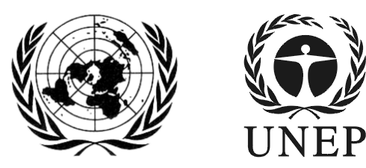 | SAICM/RM/2018/1
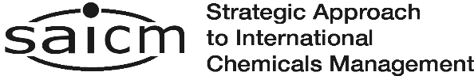 |  | Distr.: General  5 January 2018  English only
Regional meeting on the Strategic Approach to International Chemicals Management

Status of input to the 2014-2016 Strategic Approach report on progress
- Background
Reporting on SAICM implementation is a key tool in assessing progress towards the achievement of the Johannesburg Plan of Implementation’s goal of sound management of chemicals by 2020. It also helps to assess progress on the individual objectives set out in the SAICM texts.
The Overarching Policy Strategy, in paragraph 24, provides that the International Conference on Chemicals Management (ICCM) will undertake periodic reviews of SAICM. In doing so, it will receive reports from all relevant stakeholders on progress in SAICM implementation. The ICCM evaluates the implementation of SAICM with a view to reviewing progress against the 2020 target and taking strategic decisions, programming, prioritizing and updating the approach as necessary.
Paragraph 26 of the Overarching Policy Strategy also assigns to regional meetings a role in reviewing progress in SAICM implementation.
The functions of the SAICM secretariat, which are set down in paragraph 28 of the Strategy, include reporting to the ICCM on implementation of SAICM by all participants.
- Current reporting
The fourth session of the International Conference on Chemicals Management (ICCM4) requested the secretariat to develop a third progress report including achievements, strengths and weaknesses for the period 2014–2016 and an analysis of the 20 indicators of progress for consideration by the Open-ended Working Group at its third meeting (October 2018). ICCM4 also directed the Open-ended Working Group to consider the need for a report for the period 2017–2019 for consideration by ICCM5.
In order to facilitate the process, an online survey was developed. Every SAICM focal point received a separate e-mail with a personalised link to participate in the survey as it could only be submitted once per stakeholder. The results of this survey will be reflected in the progress report, which will be considered by the Open-ended Working Group at its third meeting.
The online survey for the 2014-2016 reporting period was open from 16 June to 15 September. The secretariat extended the period until 31 October 2017. At its fourth meeting (Rome 7-8 November 2017), ICCM5 Bureau decided to prolong the reporting time until 1 December 2017 and invited all members, particularly SAICM Regional Focal Points, to encourage all SAICM stakeholders to complete the online survey.
Responses received (as of 31 December 2017):
- 31 completed surveys + EU and its MS, Belgium and France (written forms): Argentina, Austria, Barbados, Belarus, Belgium (written form), Bosnia Herzegovina, Bulgaria, Costa Rica, Denmark, European Union and its Member States (written form), Finland, France (written form), Germany, Guyana, Italy, Madagascar, Monaco, Serbia, Spain, Switzerland, United Arab Emirates, Yemen, WEOG, American Petroleum Institute, AWHHE, Ecological Restaurations, ICCA, PAN, Studies Toxic Substances, OECD, UNDP, UNEP, UNITAR, WHO.

- 20 incomplete responses: Colombia, Cote d’Ivoire, Cyprus, Honduras, Hungary, Japan, Lesotho, Lithuania, Macedonia, Malaysia, Mexico, Montenegro, Russia, Sweden, Slovakia, Slovenia, Thailand, Eco Accord, ISE POP CI, BRS secretariat.
Completed responses received by region:
Africa (1): Madagascar.
Asia and the Pacific (2): United Arab Emirates, Yemen.
CEE (4+EU): Belarus, Bosnia Herzegovina, Bulgaria, European Union and its Member States, Serbia.
LAC (4): Argentina, Barbados, Costa Rica, Guyana.
Western Europe and Others Group (10 + EU and WEOG): Austria, Belgium, Denmark, European Union and its Member States, Finland, France, Germany, Italy, Monaco, Spain, Switzerland, WEOG.

