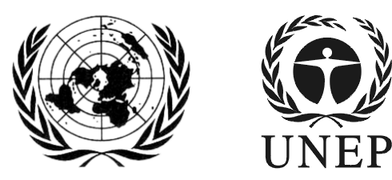 | SAICM/ICCM.5/Bureau.1/INF/5
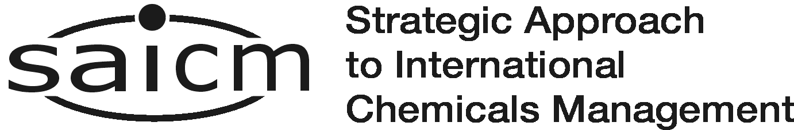 |  | Distr.: General  2 March 2016  English only
First meeting of the Bureau of the
International Conference on Chemicals Management for its fifth session
Dead Sea, Jordan
16-17 March 2016
Item 6 (c) of the provisional agenda*
Update by the secretariat on activities undertaken since ICCM4:
SAICM fundraising

Status of funding of SAICM activities July 2012 to February 2016

Note by the secretariat
The secretariat has the honour to circulate in the annex to the present note, the status of donor contributions to SAICM activities July 2012 to February 2016 for the information of participants at the present meeting.

Donor contributions to the Strategic Approach July 2012–February 2016 (United States dollars)
Contributions deposited | July to December 2012 | 2013 | 2014 | 2015 | 2016 | Total
Austria |  |  | 27 210 | 10 893 |  | 38 103
Belgium |  | 26 525 | 25 412 | 21 786 |  | 73 723
Benin |  |  |  | 8 303 |  | 8 303
Denmark | 33 647 | 44 823 | 134 005 | 62 792 |  | 275 267
European Union | 655 000 | 338 000 |  | 544 662 | 544,662 | 2 082 324
Finland | 12 953 | 13 587 | 39 526 | 40 305 |  | 106 371
Germany | 65 054 | 120 960 | 276 833 | 216 775 | 162,309 | 841 931
Guyana |  |  | 500 | 1 000 |  | 1 500
Kenya |  |  | 5 000 |  |  | 5 000
Netherlands |  | 67 843 | 65 876 | 54,466 |  | 188 185
Norway | 120 291 | 149 071 | 112 410 | 38 212 |  | 419 984
Pakistan |  |  | 2 000 |  |  | 2 000
Slovenia | 3 861 | 3 831 | 4 149 | 3 267 | 3,268 | 18 376
Sweden | 221 720 | 207 468 | 302 623 | 41 143 |  | 772 954
Sweden (Sida PCA) |  |  |  | 303 024 |  | 303 024
Switzerland | 21 790 | 12 070 | 237 451 | 345 830 |  | 617 141
United States of America | 400 000 | 370 000 | 370 000 | 370 000 |  | 1 510 000
UNEP |  | 139 400 | 280 000 | 450 000 |  | 869 400
International Council of Chemical Associations |  |  | 135 000 | 135,000 |  | 270 000
Total | 1 534 316 | 1 493 578 | 2 017 995 | 2 647 458 | 710 239 | 8 403 586

*SAICM/ICCM.5/Bureau.1/1
New pledge of 16.02.2016 from Germany (146,000 EUR) in support of SAICM secretariat
A confirmed pledge for the contribution has been received and the contribution was expected to be deposited by September 2015.
UNEP in addition to the direct cash contribution, provided in-kind contribution by way of staff time to the Secretariat.

