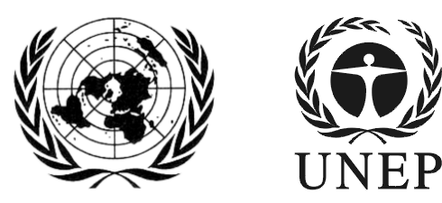 | SAICM/ICCM.5/Bureau.1/8
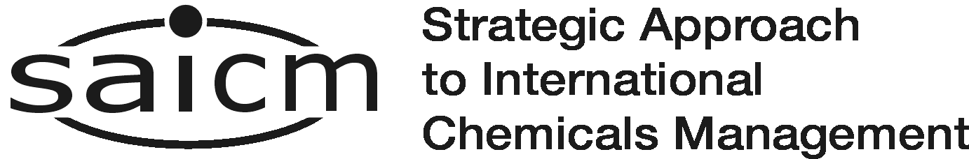 |  | Distr.: General  2 March 2016  English only
First meeting of the Bureau of the
International Conference on Chemicals Management for its fifth session
Dead Sea, Jordan
16-17 March 2016
Item 7 of the provisional agenda*
Sound management of chemicals and waste in other development processes

Concept note on International Expert and Stakeholder Workshop on the Integrated National Implementation of Sustainable Development Goals (SDGs) and International Chemicals and Waste Agreements
Note by the secretariat
1. The secretariat has the honour to circulate in the annex to the present note, a concept note on the International Expert and Stakeholder Workshop on the Integrated National Implementation of Sustainable Development Goals (SDGs) and International Chemicals and Waste Agreements scheduled to take place in Geneva, Switzerland, from 11 to 13 April 2016.
2. The overall objective of the Workshop is to advance analysis, common understanding, commitment and action to integrate the sound management of chemicals and waste effectively into national implementation of the SDGs and development planning.
ANNEX
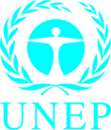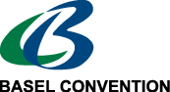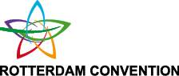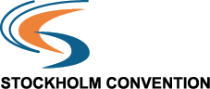

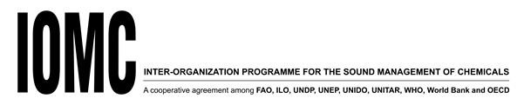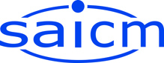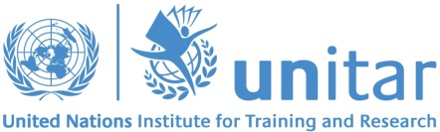

Integrated National Implementation of SDGs and International Chemicals and Waste Agreements

-

International Expert and Stakeholder Workshop

Geneva, Switzerland, 11-13 April 2016

-

Concept Note (Updated)

Background and Context
The 2030 Agenda for Sustainable Development and its 17 Sustainable Development Goals (SDGs) were adopted by the General Assembly of the United Nations in September 2015. Sound management of chemicals and waste (SMCW) is a specific target under SDG 12 on Sustainable Consumption and Production. It is also referred to under SDG 3 on Good Health and Well-being and SDG 6 on Clean Water and Sanitation. However, given that chemicals and waste affect almost all aspects of development, SMCW is relevant for, and supports the implementation of many other, if not all SDGs. SMCW is therefore of significant relevance for implementing the 2030 Agenda for Sustainable Development. Goals and targets in the area of food security, health or sustainable cities, for example, cannot be reached without SMCW. Upgrading industrial processes based on the principles of green chemistry can help to achieve SDG 9 on Industry, Innovation and Infrastructure. The flip side of the SDGs/SMCW interface is equally important: Some SDGs, such as those addressing access to information, inclusive institutions, or justice and partnerships, help create an enabling environment that could support the minimization of the adverse effects of chemicals and waste.

Challenges and Opportunities
The integration of SMCW in the 2030 Agenda for Sustainable Development is a major achievement. By fundamentally linking chemicals and waste management with the economic, environmental and social development agenda, it creates a new impetus for the implementation of international chemicals and waste agreements, i.e. multilateral environmental agreements (MEAs) on chemicals and waste, notably the Basel, Rotterdam and Stockholm Conventions, the Montreal Protocol and the future Minamata Convention, as well as other relevant international commitments and policy frameworks, including the Strategic Approach to International Chemicals Management (SAICM). However, questions arise as to how to effectively link implementation of the SDGs and SMCW at the national level. These include, for example, the following:
- How (and to what extent) is the implementation of the SDGs dependent on/affected by SMCW (or a lack thereof)? Which SDGs are particularly relevant and what are their specific chemicals and waste management dimensions and linkages?
- What are innovative existing or potential measures to link national efforts to implement the SDGs with SMCW in accordance with international chemicals and waste agreements?
- What communication, dialogue and partnerships can help to create these linkages and ensure effective mainstreaming of SMCW in national sector and SDGs-based strategies and policies?
- How can progress to advance SMCW at the national level be monitored, taking into account indicators developed under the SDGs and under international chemicals and waste agreements?

Objectives of the Workshop
To advance analysis and action for strengthening synergies between national implementation of SDGs and international chemicals and waste agreements, UNEP’s Chemicals and Waste Branch (including the SAICM Secretariat and the Interim Secretariat of the Minamata Convention), the Secretariat of the Basel, Rotterdam and Stockholm Conventions, and UNITAR have initiated a collaboration to advance analysis, outreach, and knowledge-sharing in this area. The International Expert and Stakeholder Workshop on the Integrated National Implementation of SDGs and International Chemicals and Waste Agreements takes place in the framework of this collaboration. The core support provided by the Swiss Federal Office for the Environment (FOEN) is greatly appreciated. The organizers are currently exploring additional funding opportunities to widen participation at the Workshop.
The overall goal of the workshop is to advance analysis, common understanding, commitment and action to integrate SMCW effectively into national implementation of SDGs and development planning and, through this, minimize the adverse effects of hazardous chemicals and waste on human health and the environment. Specific objectives of the workshop include the following:
- Advance analysis of how SMCW is relevant for and affects implementation of the SDGs (and vice versa).
- Capture early action and good practices by governments, industry, academia and civil society to link implementation of SDGs with SMCW and in line with international chemicals and waste agreements.
- Identify key determinants for the effective integrated implementation of the SDGs and SMCW in the context of national and sectoral development planning (e.g. governance, economic drivers, integrated financing).
- Explore practical approaches for effective monitoring of SMCW in the context of SDGs implementation, taking into account existing national and international monitoring systems and indicators.
- Identify interest in and opportunities for capacity development, partnerships and further action.
The outcomes and findings of the workshop are also expected to inform further considerations of the SDGs and SMCW interface at the national and international levels, including the intersessional process to prepare recommendations regarding the sound management of chemicals and waste beyond 2020, initiated at the fourth session of the International Conference on Chemicals Management (ICCM4). The intersessional process was mandated to consider the need for and develop recommendations regarding measurable objectives in support of the 2030 Agenda for Sustainable Development.

Expression of Interest and Participants
The Workshop will bring together approximately 50-60 participants from governments, intergovernmental organizations, the private sector, academia and civil society. A Call for Expression of Interest was issued to participants at international chemicals and waste conferences and other relevant focal points in mid-January 2016. In total, 120 potential participants submitted a synopsis of an innovative action or analysis relevant for the workshop.
Workshop participants are being identified following a review of these contributions by the organizing partners. The quality and innovative nature of submissions, relevance to the topic, geographical and gender balance considerations, and participation from diverse sectors (e.g. health, industry, agriculture, planning, finance) is being taken into account.
Additional participants will have the opportunity to contribute as panelists, discussants, or through other contributions.
Limited financial resources are available to support participation. In allocating financial support, priority is given to governmental and civil society participants from least developed and developing countries and countries in transition, taking into account the need to ensure balanced participation (regions, gender etc.).

Programme and Methods
A short pre-workshop analysis will be developed which will summarize key issues emerging from the contributions. The workshop itself is expected to explore the case studies and good practices in more detail. It is scheduled to include the following seven sessions:
- Session 1: Understanding the nexus of SDGs and sound management of chemicals and waste
- Session 2: Taking stock of early action by governments, industry, academia and civil society
- Session 3: Examining key sectors and selected SDGs in more depth
- Session 4: Identifying good practices for effective governance, outreach and communication
- Session 5: Exploring indicators of progress and effective mechanisms for monitoring
- Session 6: Adjusting partnerships and development cooperation to the new development agenda
- Session 7: Conclusions and follow-up
For additional outline on the scope of each session, please see the Annex. The Workshop will be interactive in nature and is organized around a series of presentations, panel discussion and focused discussion in breakout groups.

Partners
This workshop is organized through cooperation among the following partners:
- The UNEP Chemicals and Waste Branch, including the SAICM Secretariat and the Interim Secretariat of the Minamata Convention
- The Secretariat of the Basel, Rotterdam and Stockholm Conventions
- UNITAR
- The Inter-Organization Programme for the Sound Management of Chemicals (IOMC)

Evaluation
At the end of the workshop, a workshop evaluation will be conducted to assess the extent to which the workshop achieved its objectives, to identify lessons learned, and to obtain feedback that will help the organizers in designing future events.

Meeting outcomes and follow up actions
The workshop is expected to generate insights, guidance and recommendations for further action on the integrated national implementation of SDGs and international chemicals and waste agreements. The outcome will be widely shared and may be of interest to and inspire participants, as well as those not able to attend, to take further action. Possible follow-up action may include using insights from the workshop to inform existing projects (e.g. in the CHEmObs project), initiation of pilot projects (including identification of sources of funding), fostering international knowledge sharing, and other innovative activities considered of value. Workshop outcomes and agreed follow-up action will be captured in a summary report which could be shared in different international meetings and fora, such as UNEA2, the WHO World Health Assembly, Permanent Missions in New York, Nairobi and Geneva, SAICM Focal Points and Open-ended Working Groups, the IOMC, the EMG’s Issue Management Group on the Sound Management of Chemicals and Waste, the GEF and other interested constituencies.

Logistics
The workshop will take place in Geneva, Switzerland, 11 - 13 April, 2016. The meeting is tentatively booked to take place in the International Environment House II in Geneva.

  - Annex: Draft Outline of the Workshop Sessions
Session 1: Understanding the nexus of SDGs and sound management of chemicals and waste
Session 1 introduces the overall SDGs implementation context and the results of an initial analysis to identify SDGs and targets that apply to and may benefit from SMCW, including the chemicals and waste MEAs as well as other relevant international commitments and policy frameworks.
Session 2: Taking stock of early action by governments, industry, academia and civil society
Session 2 provides an opportunity for participants to share cases of innovative analysis and action from the perspective of different constituencies (i.e. governments, industry, academia and civil society). It also initiates the process of identifying good practices, lessons learned and knowledge-sharing.
Session 3: Examining key sectors and selected SDGs in more depth
Session 3 will go into detail regarding a small number of selected sectors and SDGs and examine how in practice SMCW can be achieved within a SDGs implementation context, thereby identifying key determinants for effective integrated implementation. The more in-depth analysis is expected to generate insights which may also be of relevance to other sectors/SDGs.
Session 4: Identifying good practices for effective governance, outreach and communication
Session 4 addresses the importance of governance, process and communication aspects that are likely to affect SMCW in a SDGs implementation context. The Session thus continues the process of identifying good practices, recognizing the value of a diversity of approaches in the context of the integration of SMCW into national sustainable development plans and strategies.
Session 5: Exploring indicators of progress and effective mechanisms for monitoring
Session 5 examines how the current draft international SDGs indicators can be applied at the national level for SMCW together with more specific indicators under international chemicals and waste agreements and other indicators of national relevance. This may also include a discussion of potential baselines and analysis of the relevance of the SAICM 20 indicators of progress towards achievement of the 2020 goal.
Session 6: Adjusting partnerships and development cooperation to the new development agenda
Session 6 examines evolving modes of development cooperation and partnerships between governments, industry, academia and civil society in a SDGs implementation context and explores how this affects development cooperation and partnerships to support SMCW.
Session 7: Conclusions and follow-up
Session 7 provides a summary of deliberations and explores possible further action by all concerned actors.

*SAICM/ICCM.5/Bureau.1/1
Here understood as hazardous waste. Nuclear waste, biological waste, sanitation waste etc. are not included
The Integrated Health and Environment Observatory for Sound Management of Chemicals
In line with ICCM Resolution IV/1

