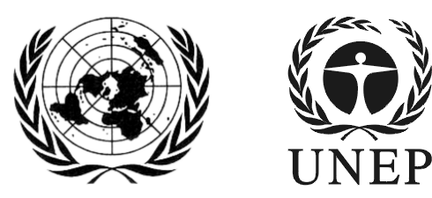 | SAICM/ICCM.5/Bureau.1/7
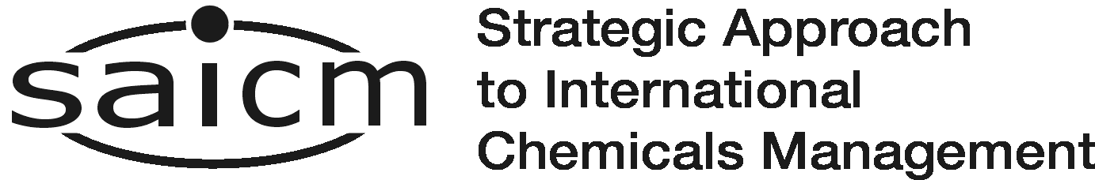 |  | Distr.: General  2 March 2016  English only
First meeting of the Bureau of the
International Conference on Chemicals Management for its fifth session
Dead Sea, Jordan
16-17 March 2016
Item 7 of the provisional agenda*
Sound management of chemicals and waste in other development processes

Consultative Experts Meeting for the Preparation of the Global Chemical Outlook (GCO-II)
Note by the secretariat
- The secretariat has the honour to circulate in the annex to the present note, a concept note on a Consultative Experts Meeting for the Preparation of the Global Chemical Outlook (GCO-II): Taking Stock and Exploring the Future of Global Chemicals Management in a Sustainable Development Context scheduled to take place in Geneva, Switzerland from 13-14 April 2016. The GCO II project is implemented by UNEP Chemicals and Waste Branch

- The overall objective of the Consultative Expert Meeting is to provide advice on a range of aspects relevant for preparing GCO- II, including identification of strategically relevant chemicals management topics considered to be essential for a post 2020 global approach, which would have as its ultimate goal to advance sustainable chemical management in a sustainable development context.

ANNEX
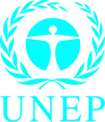

Consultative Experts Meeting for the Preparation of the Global Chemicals Outlook II

Taking Stock and Exploring the Future of Global Chemicals Management in a Sustainable Development Context

13-14 April 2016 Geneva, Switzerland
Concept note (Draft,12 February 2016)
Background and context
The Global Chemicals Outlook (GCO-I) was published in February 2013 as a first comprehensive overview of issues and challenges related to the sound management of chemicals globally. GCO-I assessed the status of health, environmental, economic and institutional factors related to the production, use, and disposal of chemicals, with a focus on issues relevant to developing countries and countries with economies in transition. While alerting ministers and decision-makers on the most pressing challenges pertaining to the changes and trends, it also gathered a set of facts, evidence and arguments to make a convincing economic case for investing in sound chemicals management.
The twenty-seventh session of the Governing Council/Global Ministerial Environment Forum held in Nairobi, 18–22 February 2013, recognized the significance of the findings of the GCO and its recommendations. The Governing Council requested UNEP to continue its work on Global Chemicals Outlooks, particularly in areas where data were found to be lacking or inadequate, and to enhance transparency through regionally balanced stakeholder involvement, inter alia, with a view to developing in the future a tool for assessing progress towards the achievement of the sound management of chemicals and hazardous wastes, including the existing 2020 goal, taking into account and building upon other existing sources of information.
The adoption of the SDGs and its recognition of sound management of chemicals for sustainable development, as well as the outcome of ICCM4 and its decision to advance a post 2020 SAICM agenda, have created a window of opportunity to shape the future of global chemicals management within the context of the 2030 Sustainable Development Agenda. With the goal to be forward looking and policy relevant, the GCO-II is expected to capture the state of scientific, management and policy knowledge to support policy makers and key stakeholders in their search to shape a post 2020 global approach to chemicals management.
Objectives of the Meeting
In the above context, and responding to the Governing Council request, UNEP will convene a consultative expert meeting on 13-14 April 2016 in Geneva to discuss the development of GCO-II. The overall goal of the meeting is to provide advice on a range of aspects relevant for preparing GCO- II, including identification of strategically relevant chemicals management topics considered to be essential for a post 2020 global approach, which would have as its ultimate goal to advance sustainable chemical management in a sustainable development context.
Specific objectives of the meeting include the following:
- Review important trends affecting international chemicals and waste management
- Discuss priorities for updating GCO I
- Identify chemicals management topics relevant for a post-2020 global approach for chemicals management that merit a state-of-the-art assessment
- Provide input to the development of TORs for thematic review papers on selected topics
- Agree on modalities, methods, and procedures for preparing the GCO-II
- Identify linkages with and opportunities to feed into the SAICM post-2020 process
- Discuss partnerships and resource considerations for completion of GCO-II
The outcomes of the meeting will be available for UNEA2 in May 2016.
Participants
The consultative experts meeting will be composed of regionally balanced, multi-sectoral scientific and technical experts from governments, international organizations, the private sector, and civil society organizations, including NGOs and academic representatives.
Three major groups will be considered in identifying participants for the consultative experts meeting. They include groups that:
- have recognized knowledge on the scientific aspects of chemical management;
- have recognized knowledge and skills related to the various “tools” and thematic issues; and
- that are positioned to analyse the economic and social trends related to chemicals and waste management and to help deliver positive changes on the ground, including governments, UN agencies, major businesses, and civil society.
Methods and approach
The consultative experts meeting will play an important role in guiding the strategy for development of the GCO II. It will review and agree on the rationale, the scope and the process to conduct relevant research on topics proposed as priorities.
An important aspect of the meeting is to provide guidance for the development of science-based and policy-oriented review papers (approximately 20-25 pp. in length) that will capture cutting edge knowledge on the status of key thematic chemicals management topics. Topics may include, but are not limited to: Understanding Global Value Chains and Trade (What Leaves, What Comes Back); Fiscal Instrument and Incentives; Global Status of Hazard Identification and Communication; Advancing Assessments of Chemical and Non-Chemical Alternatives; Greening Research and Development (“Benign by Design”); or Innovative Financing and Business Models.
The development of thematic review papers in 2016 and 2017 is expected to inform the second phase of the GCO project (2017-2018) which will focus on extracting key insights and strategic messages to be captured in GCO-II in time for the SAICM Open-ended Working Group Meeting in 2018.

Partners
The GCO II project is implemented by UNEP Chemicals and Waste Branch, working in close consultation with the SAICM Secretariat located in the Branch, the BRS Secretariat, and the UNEP Resource Efficiency Sub Programme and its two Branches, the Economics and Trade Branch and the Sustainable Lifestyles, Cities and Industry Branch. Following the practice for GCO I, the project will closely collaborate with OECD, WHO, as well as other participating organizations of the Inter Organization Programme of the Sound Management of Chemicals (IOMC).
Contact
Policy and Mainstreaming Team
Chemicals and Waste Branch
Division of Technology, Industry and Economics (DTIE)
United Nations Environment Programme (UNEP)
MIE, 11-13 chemin des Anémones
CH-1219 Châtelaine, Geneva, Switzerland
kaj.madsen@unep.org
pierre.quiblier@unep.org

*SAICM/ICCM.5/Bureau.1/1

